Decomposers and the
Carbon Cycle
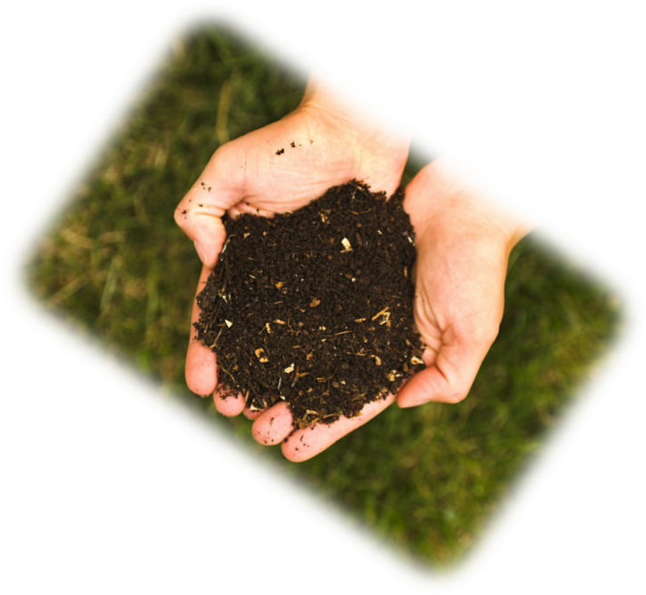

How decomposition changes
Carbon and chemical energy
The Environmental Literacy Project
2011-2012

Table of Contents

Table of Contents 2
Specifications for Decomposers and the Carbon Cycle Unit 3
Decomposers and the Carbon Cycle Timeline and Overview 3
Lesson Sequence for Decomposers Unit 6
Additional Unit Information 8
Core Lesson 1: How Do Things Decay? 10
Activity 1: Pre-assessment 12
Activity 2: What Happens To Dead Plants And Animals? 12
Activity 3: Rotten Work Investigation 13
Decomposers Pre-assessment with Commentary 15
Sample Mass Change of Jell-O and Decomposers Combined 17
Jell-O Decomposition Pictures 18
Rotten Work Investigation Procedures 19
Worksheet with Commentary: What Happens to Dead Plants and Animals? 20
Worksheet with Commentary: Rotten Work Investigation 21
Core Lesson 2: Decomposers In Ecosystems 24
Activity 1: Zooming Into Soil 25
Optional Activity: Under The Lens 26
Worksheet with Commentary: Under The Lens 28
Core Lesson 3: Decomposer Growth 31
Activity 1: Speeding Up Decomposition 32
Activity 2: Breaking and Building Molecules 33
Building Organic Molecules 36
Worksheet with Commentary: Fungus Growth: Digestion and Biosynthesis 37
Core Lesson 4: Now You See It, Now You Don’t 40
Activity 1: Evidence of Mass Change in Decomposition 41
Activity 2: The Air Around Decomposition 42
Activity 3: Accounting For Results with Claims, Evidence, and Reasoning 44
Worksheet with Commentary: Investigating the Missing Mass 45
Core Lesson 5: Modeling how Decomposers get Energy for Growth and Functioning 48
Activity 1: What Is Decomposition? 49
Activity 2: Modeling Decomposer Respiration 50
Optional Activity: Soil Flux Investigation 51
What Is Decomposition? 53
Modeling Decomposer Respiration Instructions 54
Worksheet with Commentary: Changing Dead Plants And Animals To Gases 56
Sample data: Modeling Decomposer Respiration 61
Worksheet with Commentary: Evidence of Decomposers Living In Soil 62
Core Lesson 6: Coaching and Fading for Decomposition 63
Activity 1: Application Questions 63
Worksheet with Commentary: Other Examples of Digestion, Biosynthesis, and Cellular Respiration in Decomposers 65

Specifications for Decomposers and the Carbon Cycle Unit

Decomposers and the Carbon Cycle Timeline and Overview
Lesson | Activity | Lesson Description | Core Investigation | Other Investigations  & Modifications | Tools For Reasoning | Formative Assessment | Media & Other VTTs | Required Materials
CORE 1 | 1  (20 min) | Pre-assessment |  |  |  |  |  | Unit pre-assessment
 | 2  (30 min) | Establishing the Problem: What happens to dead plants and animals? Students share their initial ideas about what happens to matter and energy when dead plants and animal decay. Students use process diagrams to explain how decomposition changes materials. |  |  | Process Tool | Embedded Formative Assessment | Decomposer Expressive Process Diagram PPT | Computer to project  Public space to record ideas  Worksheet What Happens to Dead Plants and Animals?
 | 3  (25 min) | Rotten Work Investigation: Students make initial predictions and explanations, then set up Jell-O and decomposer samples and start initial mass readings for each petri dish. Students re-mass after 3 days. Mass change is apparent after 24 hours, but visible growth of decomposers takes several days. | Jell-O mold mass change |  |  |  |  | Jell-O, Sugar-free Jell-O, Gelatin  Petri Dishes  Decomposer samples  Digital Scales  Handouts Rotten Work Investigation Procedures, Sample Mass Change of Jell-O and Decomposers Combined, Jell-O Decomposition Pictures  Worksheet Rotten Work Investigation (3 parts)
CORE 2 | 1  (20 min) | Zooming into Soil: Teacher uses a PowerPoint to zoom into soil on the forest floor. Students identify whether certain materials in the soil are organic or inorganic and if they still have chemical energy even though they are not alive. |  |  | Powers of Ten |  | Zooming into Soil PPT | Computer to project  Samples of soil
 | Opt  (25 min) | Under The Lens: Students examine soil/leaf litter/compost for evidence of decomposers and use microscopes to view microscopic organisms. |  | Modification: Prepare slides ahead of time for students to view | Powers of Ten |  | Photographs of micro-organisms (especially bacteria) | Soil/leaf/compost samples  Forceps, hand lens, droppers  Microscopes and slides/distilled water  Worksheet Under the Lens (optional)
CORE 3 | 1  (15 min) | Speeding Up Decomposition: Teacher shows students time-lapse videos of decomposers growing over time. Poses the question, Where does the mold get all the matter it uses to grow? |  |  |  |  | YouTube Videos: Fungus growth | Computer to display video  Public space to record ideas
 | 2  (40 min) | Breaking and Building Molecules: Students use paperclips to demonstrate digestion and biosynthesis in decomposers. Students then construct an account for decomposer growth using process diagrams. |  | Modification: Eliminate paperclips and just use PPT/process diagrams | Process Tool |  | Decomposer PPT | Computer to project PowerPoint  Paperclips sets  Handout Building Organic Molecules  Worksheet Fungus Growth: Digestion and Biosynthesis (2 parts)
CORE 4 | 1  (15 min) | Evidence of Mass Change in Decomposition: Teacher shows a time-lapse video of decomposing plant material and asks students: Where does the mass of the dead plant go when it decays? Students take final mass readings on their Jell-O-Decomposer systems and record their results. | Mass Change in Decomposer System |  |  | Embedded Formative Assessment | YouTube Videos: Decomposing plants | Computer to display videos  Rotten Work Investigation lab materials and worksheets
 | 2  (30 min) | The Air Around Decomposition: Students set up investigations to monitor CO₂ in the air around Jell-O-decomposers, as well as test for water as a product. Students use BTB indicator and soda lime for the investigation, but if a CO₂ probe is available, this can also be used. | Measurement of CO₂ around decomposers | Modification: Can use Vernier CO₂ probe if available. |  |  |  | Jell-O Decomposer Samples  BTB and Soda Lime  Petri Dishes and Airtight Containers  Digital Scales  Cobalt chloride test strips (optional)  Worksheet Investigating the Missing Mass (3 parts)  Option:  Vernier CO₂ Probe  2000mL respiration chamber
 | 3  (30 min) | Accounting For Results with CER: Students make claims about where mass is going in their decomposition investigations. Students share how the evidence supports their claims and what they believe is happening to the mass. |  |  |  | Embedded Formative Assessment |  | Public space to record ideas  Worksheet Rotten Work Investigation
CORE 5 | 1  (30 min) | What is Decomposition? Students construct process diagrams to explain how matter and energy change during decomposition. The PowerPoint process diagrams can be used with a reading about decomposition. |  |  |  |  | Decomposition PPT | Computer to project PowerPoint  Reading What Is Decomposition?
 | 2  (25 min) | Modeling Decomposer Respiration: Students use molecular models to demonstrate cellular respiration in decomposers. |  |  |  |  |  | Molecular Model Kits  Handout Modeling Decomposer Respiration Instructions  Worksheet Changing Dead Plants and Animals to Gases
 | Opt  (55 min) | Soil Flux Investigation: Students complete an investigation testing for the "soil flux" in different soil samples depending on whether a sugar or starch additive was given to the soil microbes. Students connect the CO₂ flux to what they observed in their Jell-O investigations. | Soil flux |  |  |  |  | Soil Samples  Sugar and Starch solutions  Respiration chambers  Vernier CO₂ Probe  Handout Sample Data: Modeling Decomposer Respiration  Worksheet Evidence of Decomposers Living in Soil
CORE 6 | 1  (25 min) | Application Questions: Students use the process tool and practices to explain transformations in different examples of decomposition, and connect to systems and scale by explaining how cellular respiration is like combustion. |  |  |  |  |  | Worksheet Other Examples of Digestion, Biosynthesis, and Cellular Respiration in Decomposers (2 parts)

Lesson Sequence for Decomposers Unit
Activity Sequence | Materials
- How do things decay? Investigation and accounts for decomposers. | Pre-assessment
A. Establishing the problem: What happens to dead plants and animals? Core Lesson 1.2 | Worksheet: What happens to dead plants and animals?
- Investigation and accounts for decomposer growth: digestion and biosynthesis.
- Investigation: Jell-O mold mass change. Core Lesson 1.3  - PE: Initial predictions and explanations  - O: Observations of mass change, data from other sources  - E: Revised arguments from evidence  - Claims: Decomposers turn some of the mass of the Jell-O into gases as they grow  - Evidence: Mold and Jell-O combined lose mass as mold grows  - Reasoning: Materials and mass/gases practices connect claims and evidence in a way that is consistent with conservation of matter and mass (with some of food mass unaccounted for). | Worksheet: Rotten work investigation (3 parts)  Handouts: Rotten work investigation procedures,  Sample mass change of Jell-O and decomposers,  Jell-O decomposition pictures
- Decomposers in ecosystems. Core lesson 2  - Zooming into soil: PPT  - Under the lens | Worksheet: Under the lens (optional)
- Digestion and biosynthesis: Growth of fungi. Core Lesson 3  - Macroscopic structure and movement: Food is broken down outside hyphae and small organic molecules move into fungus. Videos of mold growth.  - Microscopic structure and movement: PPT.  - Atomic-molecular models: Paper clip digestion and biosynthesis. | Videos: Fungus growth  Handout: Building organic molecules  Worksheet: Fungus growth: Digestion and biosynthesis (2 parts)
- What happens to the missing mass? Core lesson 4
- Wrap up investigation 1: Evidence of mass change in decomposition  - O: Mass of Jell-O and decomposer system Activity 4.1  - E: Accounting for results with claims, evidence, reasoning  - Investigation 2: Gas exchange with mold growth Activity 4.2  - PE: Predicting changes in air that accompany mold growth  - O: BTB and soda lime with decomposing Jell-O.  - E: Accounting for results with claims, evidence, reasoning Activity 4.3  - Claims: Fungi convert food and maybe oxygen into CO₂ and maybe water vapor  - Evidence: Fungi and food combined lose mass, CO₂ levels rise  - Reasoning: Materials and mass/gases practices connect claims and evidence in a way that is consistent with conservation of matter and mass (with some of animal mass and gases unaccounted for). | Worksheets: Rotten work investigation, Investigating the missing mass (3 parts)
- Modeling how decomposers get energy for growth and functioning. Core Lesson 5  - Macroscopic structure and movement: Food moves through hyphae to cells; O₂ diffuses into cells; CO₂ and H₂O diffuse out of cells. PPT  - Microscopic structure and movement: Zooming into fungal cells (glucose and O₂ in; H₂O and CO₂ out). PPT  - Atomic molecular transformations  - Process tool: PPT  - Modeling cellular respiration Activity 5.2  - Optional Investigation 3: Soil Flux Activity 5.3 | Handouts: What is decomposition?,  Modeling decomposer respiration instructions,  Sample data: Modeling decomposer respiration  Worksheets: Evidence of decomposers living in soil
- Application lesson: Coaching and fading for decomposition. Core Lesson 6
- Application questions: Using process tool and practices to explain transformations in different examples of decomposition.  - Connecting with Systems and Scale: How is cellular respiration like combustion? | Worksheets: Other examples of digestion, biosynthesis, and cellular respiration in decomposers (2 parts)

Additional Unit Information

Targeted Grades: 6-12

Key Concepts: Biomass, Biosynthesis, Chemical Energy, Cellular Respiration, Decomposition

Vocabulary
- Biomass
- Biosynthesis
- Carbon Dioxide
- Chemical Energy
- Cellular Respiration
- Decomposition
- Digestion
- Inorganic Matter
- Mass
- Molecule
- Monomer
- Organic Matter
- Polymer
- Process

Materials

General Resources
- Computer to project
- Public space to record student ideas (e.g., white board, overhead, etc.)
- Molecular model kits (e.g., LabAids, Balls/Sticks, Clips/Strips, or other)
- Decomposition PowerPoint, with process tool & powers of ten diagrams

Lab Materials
- Core Lesson 1 Materials
  - Jell-O, Sugar-free Jell-O, Gelatin
  - Petri Dishes
  - Decomposer samples
  - Digital Scales
- Core Lesson 2 Materials
  - Soil/leaf/compost samples
  - Forceps
  - Microscopes and slides
  - Distilled water
  - Hand lens
  - Droppers
- Core Lesson 3 Materials
  - Paperclips sets
- Core Lesson 4 Materials
  - Jell-O-Decomposer Samples
  - BTB
  - Soda Lime
  - Petri Dishes and Airtight Containers
  - Digital Scales
  - Cobalt chloride test strips (optional)
  - Vernier CO₂ Probe (optional)
  - 2000mL respiration chamber (optional)
- Core Lesson 5 Materials
  - Soil Samples
  - Sugar and Starch solutions
  - Respiration chambers
  - Vernier CO₂ Probe
  - BTB and soda lime could be used too with airtight containers

Re-Usable Student Handouts/Resources
- YouTube videos
- Sample Mass Change of Jell-O and Decomposers Combined
- Jell-O Decomposition Pictures
- Rotten Work Investigation Procedures
- Building Organic Molecules
- What is Decomposition?
- Sample Data: Modeling Decomposer Respiration
- Modeling Decomposer Respiration Instructions

Consumable Student Worksheets
- What Happens to Dead Plants and Animals?
- Rotten Work Investigation
- Under the Lens
- Fungus Growth: Digestion and Biosynthesis
- Investigating the Missing Mass
- Changing Dead Plants and Animals to Gases
- Evidence of Decomposers Living in Soil
- Other Examples of Digestion, Biosynthesis, and Cellular Respiration in Decomposers
- Predicting and Explaining and Example of Chemical Change in Decomposition

Recommended Resources
Hogan (1994). Eco-Inquiry: A Guide to Ecological Learning Experiences in Upper
Elementary/Middle Grades. Dubuque, IA: Kendall/Hunt Publishing.
SCIIS (Lawson, Knott, Karplus, Their, Montgomery (1978) SCIIS Communities and
SCIIS Ecosystems Teacher’s Guides. Chicago: Rand-McNally.
North Cascades & Olympic Science Partnership. (2007). Matter and Energy in Living
Systems. Images and instructional ideas on Exploring Ecosystem activity were modified
with permission from the North Cascades and Olympic Science Partnership, Western
Washington University, www.ncosp.wwu.edu. Developed with funding by National
Science Foundation Grant No. DUE-0315060.

Acknowledgments
Writers: Lindsey Mohan with assistance from Jennifer Doherty, Jenny Dauer, Debi Kilmartin, Marcia Angle, Cheryl Hach, Cathryn Ratashak, and Amy Lark.
Reviewers: Charles W. Anderson and Daniel Gallagher

Core Lesson 1: How Do Things Decay?

Time/Duration: 75 minutes
Activity 1: Unit Pre-Assessment ~20 minutes
Activity 2: What Happens To Dead Plants And Animals? ~30 minutes
Activity 3: Rotten Work Investigation ~25 minutes

Guiding Question: When living things die, what happens to the stuff they were made of?

Model Response:
Alex | Blake | Carmen
When plants and animals die they decompose and turn into soil. | Decomposers eat the dead plants and animals for cellular respiration. Some of the matter becomes energy for decomposers, but the extra turns into soil. | Decomposers use the organic carbon in the dead plants and animals for cell respiration and turn the matter into gases (carbon dioxide and water vapor) that go into the air. A small portion of the organic materials are turned into minerals that enrich the soil.

Decomposition is the process by which organic matter (mostly polymers—large organic molecules) is broken into monomers—small organic molecules--and oxidized by decomposers (mostly bacteria and fungi) through the processes of digestion and cellular respiration. When oxidized, most of the original matter found in the biomass is transformed into gases given off to the air, which is the process explained by Carmen (Level 4). Carmen recognizes that despite the appearance that decaying plant and animal matter is “going into the soil” the vast majority of the decaying matter is actually released into the air as gases. Unlike Carmen, students at Level 2 and Level 3, like Alex and Blake, are still working with the solid-solid nutrient cycle framework. This cycle focuses on matter recycling between solid forms from decaying biomass to soil and back into biomass again when plants absorb soil minerals. Gases play no part in this type of explanation about matter recycling. Given this solid-solid nutrient cycle, it makes sense that Blake would explain that through cellular respiration decomposers change decaying matter into energy and soil. Alex also identifies soil as the primary destination for decaying matter. Both students will need to collect evidence on changes in mass of decaying matter, changes in mass of soil/growing medium, and changes in the air around decaying materials.

Learning Objectives:
Given that your students may begin the unit with different levels of understanding, the goals for learning will vary. The Rotten Work investigation will provide students with an opportunity to observe a decomposer (mold) growing on Jell-O, and to make careful observations and measurements of mass as an indicator of growth and cellular respiration. For many students, growth is simply “getting bigger”, so measuring mass as a way of describing growth may be new for students. The investigation will also provide evidence that, because the entire system loses mass, not all food consumed becomes part of the body structure which will be used as evidence as students learn more about cell respiration later in the unit.

Rationale & Background:
Students will bring many ideas about decomposition to your classroom. The most common ideas might be, “decaying matter turns into soil” or “bacteria eats decaying matter for food,” or even “the weather causes decomposition.” All of these ideas are correct to some degree. Yes, decomposition is influenced by factors like temperature and moisture. Yes, decomposition results in substances/minerals being returned or added to the soil. But when students are probed further and asked to explain what happens to the matter or the energy during decomposition, they are often at a loss. The vast majority of the dead organic matter is transformed into carbon dioxide and water through cellular respiration. The vast majority of chemical energy in the organic matter is transformed into kinetic energy and heat. These transformations come about because decomposers are doing essentially the same processes people do when they eat—decomposers are digesting organic matter, using some of it to grow, but oxidizing most of it to meet their energy needs.

Lesson Description:
In this lesson students share their ideas about decomposition on a unit pre-assessment. Following the pre-assessment, students have the opportunity to share and discuss their ideas aloud, and use expressive process diagrams to develop explanations about decomposition. Students then set up Rotten Work Investigations, where they will record mass changes in a decomposer system over time (decomposers growing on Jell-O). This investigation provides evidence—in the form of mass measurements—for cellular respiration, as well as visible observations of growth in decomposers.

Lesson Materials:
General
- Public space to record student ideas (board, projector, smart board, etc.)
- Decomposer PowerPoint: Expressive Process Diagram for Decomposition.
- Prepared Petri dishes
  - Set of petri dishes prepared with standard Jell-O (contains sugar)

  - Various sources of decomposers- mold off bread, small piece of brown leaf, small green leaf, mold off fruit, soil bacteria from different soils, composting material, swabs that have touched surfaces areas--fingers, desktops, drinking fountain, etc.
- Masking tape & pen (or some other way to label each group’s samples)
Per Group
- Assortment of petri dishes (at least 3 and up to 8)
- Assortment of decomposers (from those provided above)—note, students can bring in their own decomposing materials, or collect samples from around the school if desired.
- Instruction Handout Rotten Work Investigation Procedures (to be returned and reused)
Per Student
- Unit Pre-Assessment
- Worksheets What Happens To Dead Plants and Animals? and Rotten Work Investigation

Advance Prep:
- Have computer and PowerPoint ready to project.
- Jell-O Petri Dish Preparation: Follow Jell-O recipe. Fill petri dishes with solution and cool in the refrigerator or on a counter for at least 2 hours with the petri dish lids on. One small box makes about 12-16 petri dishes. Choose a color of Jell-O (for example, yellow) that will allow students to see decomposer growth clearly.
- Decomposer Sample Preparation: Collect an assortment of decomposer samples. Soil, dead leaves, and dust or lint (as well as most other materials in our environments) should have mold spores in them. Have swabs available for students to sample surface areas in classroom.

Activity 1: Pre-assessment

Time: About 20 minutes

Rationale and Description:
The pre-assessment is useful for two purposes:
- Your students’ responses will help you decide how much detail you want to include, particularly details about decomposition. If your students are mostly at Level 2, you may want to save some of those details for later.
- Your students’ responses will provide a starting point for discussions about the focus for this unit.

Directions:
- You can administer the assessment either online or with paper and pencil (it will fit on the front and back of one page).
- Explain that they will be taking a pretest that has questions about decomposition (and what happens to dead plant and animal matter as it decays).
- Explain the purpose of the pre-assessment to your students:
  - It will help you as a teacher understand how they think about decomposition.
  - It will help our research project to develop better teaching materials and activities by helping the researchers to understand how they think and how they learn.
  - It will help them to think about what they know and what they would like to learn.
- Give the students about 20 minutes to complete the test. Pass out the worksheet What Happens to Dead Plants and Animals? as students complete pre-assessment (if you are completing these activities in same class period).

Activity 2: What Happens To Dead Plants And Animals?

Time: 30 minutes

Rationale & Description:
As students participate in this unit, they will collect evidence and develop explanations about decomposition. The evidence they collect will help students explain where matter and energy go during decay. This activity focuses on eliciting students’ prior knowledge about decomposition. Students are presented with three explanations about decomposition from Alex, Blake, and Carmen. They must consider what each of the explanations says about where mass and energy go, and then write their own explanations about decomposition using an expressive version of the process diagram. You may want to scaffold students’ explanations more or less depending on their experience with the process diagram.

Directions:
- Pass out the worksheet What Happens to Dead Plants and Animals? In a public space—overhead, board, computer screen—write the question, “What happens to dead plants and animals? Where does all the “stuff” go?” Allow students 5 minutes to write down their ideas to this question on the worksheet. Then give students about 3 minutes to discuss in partners before sharing aloud. They can add to or revise their ideas as they discuss in partners.
- Give students about 5-7 minutes to share their ideas aloud. You will need to record the most salient points that students share in a public space. As students share, try to hone in on the key ideas the students have about decomposition, prompting them to explain where matter or energy is going when living things die and then decay. Some example prompts might be:
  - You mentioned that decaying matter goes into the soil. How does this happen?
  - You mentioned that decomposers are eating the decaying matter. Why do they do this? What do they get from the decaying matter?
  - You mentioned the word “energy”. Does the decaying matter still have energy?
- The next part of the worksheet presents three explanations about moldy bread. Ask students to read the three explanations by Alex, Blake, and Carmen and choose which one they feel is best. Consider having your students “vote” on which explanation is the best and record this vote in a public space to revisit later in the unit.
- With the remaining time, use Decomposer PowerPoint that has the expressive process diagrams for decomposition. These diagrams have students share their ideas about matter and energy “needs” that must be present for decomposition, and how these needs change through the process. After using the process diagram PowerPoint as a whole group, students will need to record their initial ideas on their worksheet. On the backside of the worksheet students can construct their own process diagram to explain decay. Students will need time to provide a written explanation about decomposition and their own process diagram before moving on to the Rotten Work Investigation in the next activity.

Embedded Formative Assessment

Question: What happens to dead plants and animals?

Activity 3: Rotten Work Investigation

Time: 25 minutes on the initial day, 5-10 minutes for measurement days, 25 minutes for worksheet

Rationale & Description:
Students will conduct an investigation to measure mass changes in decomposers and their food source over time. Unlike the mealworm study, students cannot easily separate the decomposers from their food source, but they can measure mass changes in the combined system over time. This activity helps students conclude that some of the food ingested by decomposers is being lost by the system, leaving open the question about where the mass goes during decomposition. The actual decomposer investigation can be completed in several ways. Alterations can be made, but keep in mind that regardless of the alterations, students will need to measure the mass changes in the decomposition system over time. The proposed investigation below uses Jell-O as the growing medium/food source, but samples of decomposers can come from various places depending on other instructional goals you have for students (for example, if you want students to compare decomposers in natural soil versus chemically treated, to compare “cleanliness” of different surface areas around the school, or to compare rates of decomposition of the same substance in a variety of conditions). You could also set up petri dishes with Knox gelatin (mostly a protein substance) and/or sugar-free Jello-O in addition to regular Jell-O. This could be an opportunity to discuss and compare food sources for decomposers. The options are endless for additional learning, but most importantly remember to choose an experimental set-up where students can keep track of mass change over time.

Directions:
- Prepare the petri dishes with Jell-O the night before the investigations are to be started. The investigations will show mass changes within a 24-hour period, but students will need several days to show significant, visible decomposer growth.
- Talk to students about food sources for decomposers. Jell-O has a lot of sugar within its solution. Consider showing students the actual nutrition labels for each substance and discuss the polymers and monomers that are found. This will connect to what students have learned in other units.
- Pass out the lab investigation handout Rotten Work Investigation Procedures, one to each group. This handout includes directions for setting up students’ decomposition samples (modify as needed). Students will also need their own investigation worksheet to record predictions and data. NOTE: the backside of the worksheet will not be used until later in the unit when students are accounting for their results.
- Describe the lab investigation to students. Students will be placing decomposers onto Jell-O petri dishes. Have students first make predictions about what they expect would happen to decomposer and Jell-O mass overtime.
- Then have students set up their decomposer samples following the instruction handout. Students will gently place items that contain mold/hyphae/fungus on the petri dishes and label its contents. If swabbing areas around the classroom a clean Q-tip works well; then gently touch the gelatin with Q-tip and wait for the results. Having someone cough onto a petri dish is pretty visual in the end also!
- Students will need to record the sample and initial mass of each petri dish on their data table.
- Remember to place all decomposition samples in a dark, warm place, although they can be placed in other locations around the room. (Just avoid blowing air, like fans and vents, and cool areas in your classroom.)
- Within 2-3 days you will start seeing growth of all kinds of decomposers and begin recording what you observe and taking mass measurements. Students should record mass change after only 1 day, and then wait and record the final mass change after 3 or more days, depending on your teaching schedule. The longer they grow, the more obvious the mass change and decomposer growth. During the first week the solid solution will turn liquid and a mass loss will be noticed depending upon the decomposer living in each petri dish.
- Observations should be made as carefully as possible. Measuring the size of colonies or hyphae using graph paper transparency over the top of petri dish to approximate the percentage of petri dish covered with decomposers (Day 3= 11% covered in hyphae, Day 7= 67%) OR counting group numbers and measuring their size as they grow (Day 3=2 colonies: one is 2cm by 3cm and second is 1cm by 1.2cm). Stay consistent throughout making observations. Modify the student handout as desired depending on the observations you would like students to make.
- If time permits, observe colonies growing on petri dishes and look under a dissection microscope if available. Certainly observe the colonies and hyphae under a magnifying glass, and take this opportunity to remind students that they are viewing the system at the microscopic scale. Students may notice that the Jell-O gets mushy underneath the mold colonies, but is more solid in areas that are not exposed to mold; evidence that the mold is “eating” the Jell-O.

Decomposers Pre-assessment with Commentary

Level 4 (correct) responses to the questions are in blue bold italics below. There are also comments connecting the questions to unit activities in blue italics.

1. An apple falls from a tree and lies on the ground. After a few weeks the skin and flesh of the apple have rotted and only a few seeds are left on the ground. The seeds weigh less than the original apple. What happened to the matter that used to be in the apple?

Which of the following statements is true? Circle the letter of the correct answer.
a. ALL of the matter is still somewhere in the environment, OR
b. SOME of the matter was consumed by the decay process and no longer exists.
Circle the best choice to complete each of the statements about possible places where the matter from the apple might go.
How much of the matter in the apple goes into the AIR? | All or most | Some | None
How much of the matter in the apple turns into HEAT ENERGY? | All or most | Some | None
How much of the matter in the apple goes into the SOIL? | All or most | Some | None
How much of the matter in the apple goes into WATER? | All or most | Some | None
Explain your choices. What happens to the matter in a apple as it decays?
Level 4 responses will recognize that the matter (flesh and skin) of the apple is consumed and digested by decomposers. Some mass will contribute to decomposer biomass, but most will be used by the decomposers for cellular respiration and lost to the atmosphere as gaseous waste (CO₂ and water vapor).

Level 3 students may convert matter to energy and thus choose that some portion of the mass turns into heat energy. Level 2 students are likely to indicate that most of the apple’s mass goes into the soil, especially since in the question stem the apple is resting on the ground.

2. A loaf of bread was left alone for 2 weeks. 3 different kinds of mold grew on it. Assuming the bread did not dry out, which of the following is a reasonable prediction of the weight of the bread and mold after the 2 week period?
a. The mass has increased, because the mold has grown.
b. The mass remains the same as the mold converts bread into biomass.
c. The mass decreases as the growing mold converts bread into energy.
d. The mass decreases as the mold converts bread into biomass and gases.

3. When a tree is alive it has energy stored in its living parts (roots, trunk, branches and green leaves). When the tree dies all the parts are still there (including fallen brown leaves). How much of the energy stored in the living tree is still there in the dead tree?
a. ALL of the energy
b. MOST of the energy (OK if the explanation identifies organic materials such as sugar that are lost when the tree dies)
c. SOME of the energy
d. A LITTLE of the energy
e. NONE of the energy
What kinds of energy are stored in the dead tree (if any)? How are they connected to the energy in the living tree?
Level 4 responses will recognize that chemical potential energy is stored in the (C-C and C-H) bonds of organic substances that make up the tree, and that this is true whether the tree is alive or dead.

Levels 2 and 3 may believe that some or all of the energy in the tree is associated with being alive, so it disappears when the tree dies.
What happens to the energy stored in the tree when the dead tree decays?
Level 4 responses will recognize that the chemical potential energy stored in the tree will be released when the matter in the tree is ingested by decomposers and used for cellular respiration. They may indicate that the CPE is transformed into kinetic and heat energy and lost to the environment.

Level 2 and 3 may indicate that energy is involved in decay, with Level 3 responses explaining that the tree is a source of energy (food) for decomposers, and Level 2 responses explaining that the decomposers use energy to break down the materials in the tree.

4. A potato is left outside and gradually decays. One of the main materials in the potato is the starch, which is made of many sugar molecules (C₆H₁₂O₆) bonded together. What happens to the atoms in starch molecules as the potato decays? Circle True (T) or False (F) for each option.
T F Some of the atoms are changed into soil nutrients: nitrogen and phosphorus.
T F Some of the atoms are used up by decomposers and no longer exist.
T F Some of the atoms go into the air in carbon dioxide.
T F Some of the atoms are turned into energy by decomposers.
T F Some of the atoms go into the air in water.

5. Answer these true-false questions:
True False Carbon is a kind of atom.
True False Carbon is a kind of molecule.
True False There is carbon in an insect’s muscles.
True False There is carbon in an insect’s stomach.
True False There is carbon in an insect’s shell.

Sample Mass Change of Jell-O and Decomposers Combined
Petri dish | Observations (Second day) | Starting Mass  (g) | Second day  (g) | Mass Change in 24 hours (g)
1. Rain barrel water | Jell-O breaking down | 46.31 | 46.02 | -0.29
2. Bird seed from ground | Breaking down | 46.79 | 46.42 | -0.37
3. H2O from decomposing leaves in cat water bowl (outdoors) |  | 46.50 | 46.26 | -0.24
4. Dirt from roots of weeds (see photos on following page) | Breaking down | 49.33 | 48.70 | -0.63
5. Decaying leaf | Slimy; breaking down | 55.09 | 54.76 | -0.33
6. Fresh fallen leaf |  | 43.54 | 43.27 | -0.27
7. H2O from dog pool |  | 40.57 | 40.23 | -0.34
8. Swabbing from kitchen faucet |  | 50.30 | 50.01 | -0.29
9. Swabbing from dog mouth |  | 66.40 | 66.13 | -0.27
10. Swabbing from human mouth |  | 47.73 | 47.42 | -0.31
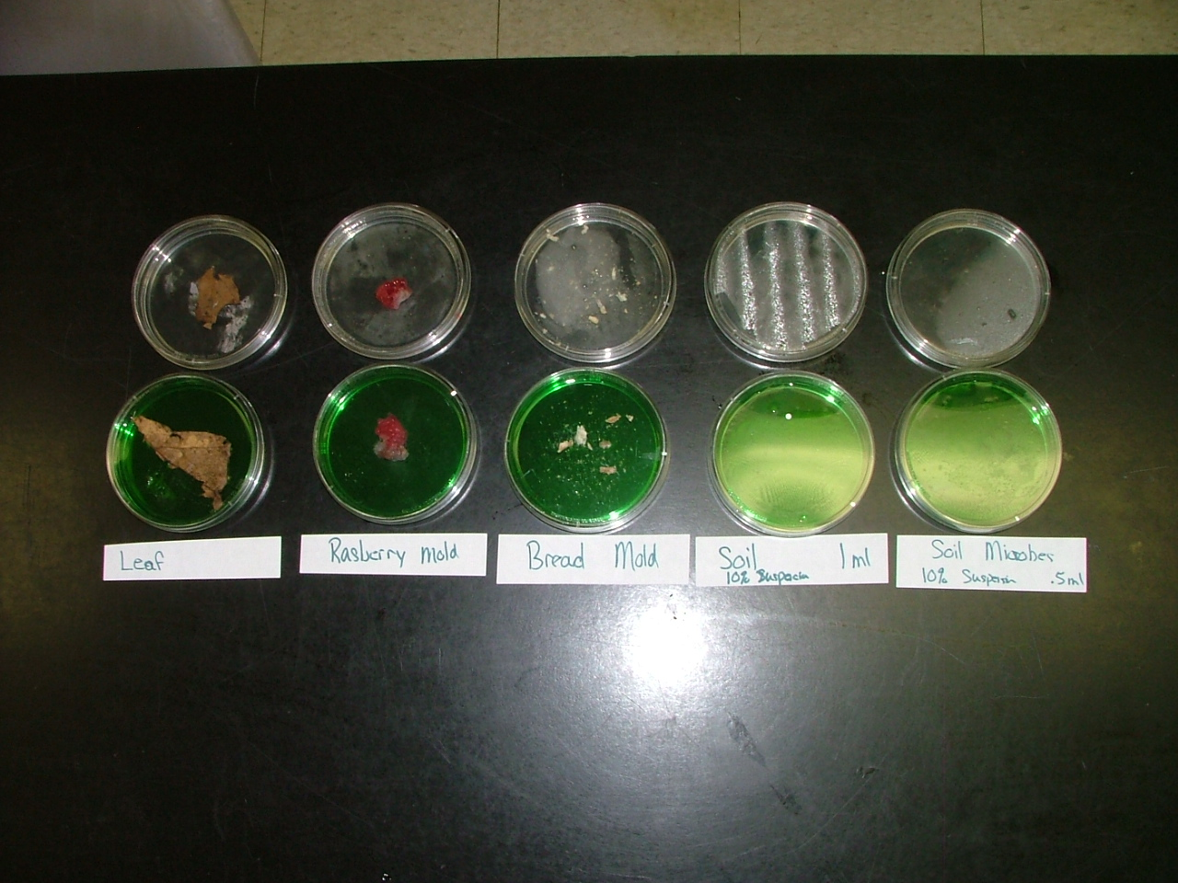

Jell-O Decomposition Pictures

Starting Observation | One Week Later
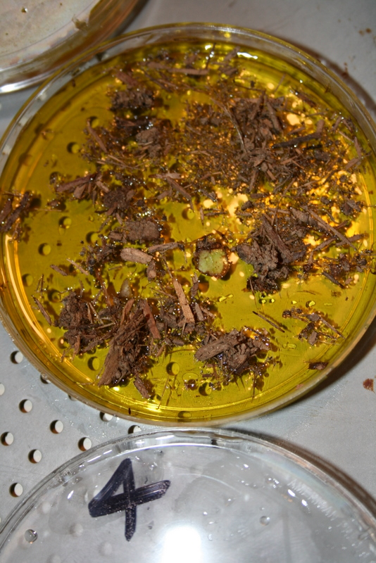 | 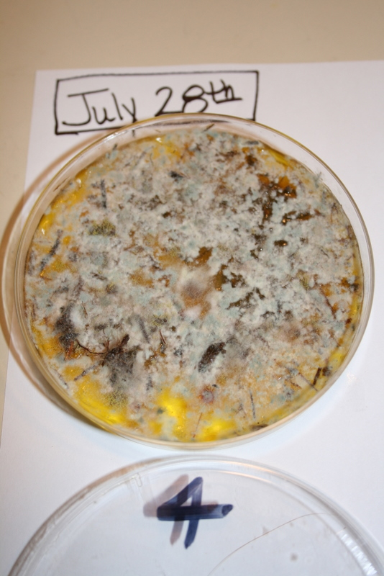
In this sample, the dirt and mulch from around the roots of a plant were placed onto a petri dish with yellow Jell-O. After being allowed to grow for 1 week, the decomposers are obvious. Mass measurements indicate that during the first week the system was losing on average 0.44 g of mass each day (i.e., starting mass measurements were 45.15g and on the second day were 44.84g).

Rotten Work Investigation Procedures

Materials:
- Petri dishes filled with Jell-O
- Decomposer samples
- Digital scale
- Lab Investigation sheet
- You may also need: Q-tips and eyedroppers

Procedures:
- Obtain the correct number of petri dishes. Your teacher will tell you how many petri dishes to get. Each petri dish has been filled with Jell-O (sugar). Over the next week you will grow decomposers on each of your dishes. You will keep track of the MASS CHANGE of your dishes as the decomposers grow and make observations of decomposer growth.

- When you add your decomposers to the petri dishes you will need to carefully label each dish with your group name or number, and the decomposer sample you are adding. Assign one person in your group to be responsible for labeling all the dishes as decomposers are added.

- Next, you will need to add your decomposers to the petri dishes. You can do this in several ways. For example, you can gently place the decomposing materials (like a moldy piece of bread) on top of the Jell-O. You might also “swab” the sample onto the Jell-O, dipping or wiping the swab on a contaminated surface first, then transferring the decomposers to the Jell-O. Your teacher might have you add a liquid solution of decomposers using an eyedropper. Simply place several drops of the solution on the Jell-O. Keep track of which decomposer sample you are adding to each petri dish. Make sure to label each dish as you go.

- The last step is to take the mass measurement of each dish. In your data table write down the description of your decomposer sample. For example you might write, “Sample 1: Moldy bread.” Turn on your digital scale until it reads 0.00. Then place the entire petri dish onto the scale. Record the start mass on your investigation worksheet for each of your samples.

- Place your decomposer samples in a place designated by your teacher. You will want the location to be slightly warm and will not want to have a fan or air conditioning vent blowing onto the samples. Your teacher might want you to experiment with different temperatures and lighting, so follow directions from your teacher!

Time to sit back and let your decomposers grow!

Name:_____________________ Period:____ Date:_________

Worksheet with Commentary: What Happens to Dead Plants and Animals?

1. When leaves fall from trees they land on the forest floor. With enough time these leaves “decompose”. Like leaves, animals may die in the forest and decompose. What happens to the matter that makes up these dead plants and animals?
Along with the pre-test, this question and the next will help you assess where your students are in their understanding. Many students will probably indicate that most of the matter will end up in the soil.

2. Do the dead plants and animals still have energy? If so, what form of energy do they have? If not, where did the energy go?
Many students will probably indicate that dead plants and animals no longer have energy, and that the energy they had when alive disappeared when they died.


3. Here are three explanations about what happens when bread begins to grow mold and rot. Circle the one you think is best.
Alex: Mold grows on the bread because the bread is rotting. Mold just helps the bread rot faster.
Carmen: When mold eats the bread it turns the bread into gases that go into the air.
Blake: Mold eats the bread and it turns the bread into energy during cellular respiration.

Why do you think your choice is best?
Alex, Blake, and Carmen generally represent Level 2, Level 3, and Level 4 reasoning, respectively. Students’ choices of the explanation they liked best can give you a quick indication of what level they are at—but not as accurate an indication as the pretest.

5. Write your own explanation for how something “rots”. What happens to the matter that makes up the rotting material? What happens to energy during the rotting process?
At this point, students’ responses are likely to be low level. They may explain that rotting matter breaks down and turns into soil. They may explain that the energy disappears.
Name:_____________________ Period:____ Date:_________

Worksheet with Commentary: Rotten Work Investigation
Initial Explanation and Prediction
When mold grows there are hidden chemical changes—transformations in matter and energy that take place when molecules are split apart and their atoms combine into new molecules. In chemical changes reactants (materials that are in the system before the change) always change into products (materials that the reactants change into).
In this investigation you will grow mold on Jell-O for a few days, so you will have to figure out what the reactants and products are when the mold grows. Think about what materials are losing mass (that would be the reactants) and what materials are gaining mass (that would be the products). Try explaining and predicting how those materials change.
Your explanation: How are reactants changing into products when mold grows?
It is not important for students’ explanations to be correct at this point. Their explanations will give you a chance to evaluate their levels of reasoning:
- Do the explanations focus on actions and events more than matter and energy (Level 2)?
- Do the explanations focus on matter and energy, but with problems such as matter-energy conversion (Level 3)?
- We generally would not expect students at this point to successfully trace matter and energy (Level 4)

Your prediction: What changes in reactants or products could we measure or observe?
A key thing to look for here is whether they can make predications that match their explanations.

Using the Process Tool to show your explanation and prediction: Show your ideas about how matter and energy change when mold grows on the process tool diagram below.
This is a “translation” task: Can they take the key words from their explanations and put them appropriately into the process tool diagram?
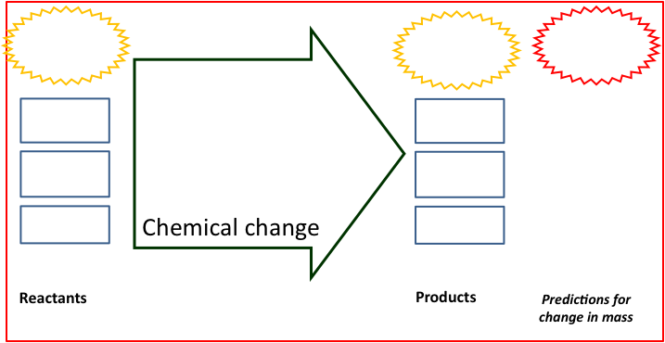
Name:_____________________ Period:____ Date:_________

Measurements During the Investigation

My Data and Observations:
 | Decomposer Sample | Start Mass | After 1 Day | End Mass | Mass Change
1 |  |  |  |  | Should be lower
2 |  |  |  |  | Should be lower
3 |  |  |  |  | Should be lower
4 |  |  |  |  | Should be lower
5 |  |  |  |  | Should be lower
6 |  |  |  |  | Should be lower
7 |  |  |  |  | Should be lower
8 |  |  |  |  | Should be lower

Observations
Describe what you see happening on your Jell-O dishes. Is anything growing?
Students should describe any growth as well as noticeable changes in the gelatin.

Results
Briefly summarize the main patterns that you saw:
What gained mass during your investigation?
Students should be able to notice that decomposers have grown (gained mass).

What lost mass during your investigation?
All Jell-O plates should have lost weight.

Explaining Your Results
Claims—your revised explanation: How are reactants changing into products when mold grows?
As with their initial explanations, it is not essential that their explanations be correct at this point. You should check to see if they have modified their explanations to be consistent with the evidence that they have collected.

Using the Process Tool: Show your new ideas about how reactants changed into products on the process tool diagram below. Again, the key question here is whether the process tool is consistent with their written explanations
Evidence—the measurements that support your explanation: What are the key observations and measurements that support your explanation?
The key question here is how well they select and summarize the evidence that is relevant to their claims.
Reasoning—connecting claims to evidence and scientific principles
Connecting explanations and evidence: How does the evidence support your explanation?
The key question here is whether they connect claims and evidence. Do they consider possible negative as well as positive evidence?
Connecting evidence and principles. Does your explanation follow the principles that apply to chemical changes?
Yes No Not sure Conservation of matter: Materials (solids, liquids, or gases change into other materials, but matter is not created or destroyed.
Yes No Not sure Conservation of mass: The masses of reactants and products are equal.
Yes No Not sure Conservation of energy: Energy is not created or destroyed.
Yes No Not sure Conservation of atoms: Atoms are not created or destroyed.
For these questions note the consistency with principles rather than the accuracy of their evaluations. If their explanation is not consistent with the principles, are they aware of it? How confident are they in applying the principles?

Core Lesson 2: Decomposers In Ecosystems

Time/Duration: 55 minutes
Activity 1: Zooming Into Soil ~20 minutes
Optional Activity: Under the lens ~25 minutes

Guiding Question: Where are decomposers in our ecosystems? What do they do?

Model Response:
Alex | Blake | Carmen
Decomposers are every-where but they mainly grow on rotting food. They eat dead stuff or rotten food to stay alive and this also helps us because they get rid of our waste. | Some decomposers we can see but some are microscopic. They eat dead organic matter and turn it into nutrients in our soil through cellular respiration. Then plants use these nutrients to grow. | Decomposers can be single cells or multi-cellular. Through cellular respiration, they change organic matter into gas (and some soil nutrients). They do this for the chemical energy in the organic matter.

Decomposers are found at both the microscopic scale and the macroscopic scale, and are typically more diverse in ecosystems with warm, moist conditions for growth, and especially in ecosystems where there is a constant supply of organic biomass to consume. As Carmen (Level 4) describes, some decomposers, like bacteria, are single-celled organisms, but there are many decomposers (like fungi and macroinvertebrates) that are multi-cellular. Just like animals, these organisms need a steady supply of chemical energy found in organic biomass. Blake (Level 3) recognizes that decomposers are performing cellular respiration and likely sees parallels to animal metabolism, but he also focuses on minor products of decomposition (soil nutrients). Alex (Level 2) seems to associate decomposers with “rotten food” and knows that decomposers are eating the dead organic matter, but has yet to learn that decomposers are functioning very similarly to animals when animals eat food, and doing this for the very same reason (to obtain energy).

Learning Objectives:
Students may be familiar with certain decomposers such as earthworms and other soil macroinvertebrates, but less so with microinvertebrates and bacteria. Depending on their level of understanding, students may not know how decomposers contribute to the decay of organic materials (i.e., by consuming them). Finally, students may or may not recognize that the organic materials in soil are the same as in the plants and animals from which they came.

Rationale & Background:
Decomposers play a vital role in our ecosystems. Some ecosystems, like deserts and the alpine tundra, have decomposers but their diversity and role in the ecosystem is not as pronounced as what we see in temperate forests and rain forest ecosystems. Every year an amazing spectacle unfolds as leaves fall from trees, piling up on the forest floor and seemingly disappear through the winter, spring, and summer. Why is it that these leaves do not pile up year after year? The forest floor is an excellent illustration of decomposers at work in our ecosystems and can be used to establish a problem about where the decomposing organic matter goes when it seemingly disappears.

Lesson Description:
In this lesson students begin by Zooming Into Soil on the forest floor. Students discuss the substances found in soil and whether they are organic (with chemical energy) or inorganic. Students then engage in a decomposer identification activity where they sift through leaf litter and soils, looking for evidence of decomposers. Students can also prepare microscope slides of decomposers.

Lesson Materials:
General
- Zooming into Soil PowerPoint
- Computer ready to project PowerPoint and optional video
Per Group
- Soil/leaf/compost samples
- Forceps
- Hand lenses
- Droppers
- Microscopes and slides/distilled water
- Worksheet Under the Lens (optional)

Advance Prep:
- Have computer and PowerPoint ready to project
- Microscope Slide Preparation: Either prepare slides in advance or have students prepare slides during class. Do this by mixing samples of soil and leaf litter with distilled water, and using an eyedropper to transfer several drops of solution to slides.

Activity 1: Zooming Into Soil

Time: 20 minutes

Rationale & Description:
Students likely see soil as simply “dirt”, an inorganic form of matter found in almost every ecosystem. Students may acknowledge that soil contains living organisms but only recognize the most iconic and visible ones, such as earthworms. In this activity, you will zoom into a forest floor looking closer at the organisms and the materials that make up a sample of soil and leaf litter. Students will examine the organisms and talk about where they fit on the Powers of Ten scale, and will also examine the materials and decide whether they are inorganic or whether they are organic and therefore a source of chemical energy for the decomposers living in the soil.

Directions:
- Show students a cup of soil, placed in a transparent container, like a beaker or glass. Ask students to discuss with their partners, “What living things might you find in the cup of soil?” After 1-2 minutes, have students share aloud, recording their list of living things in a public space. After generating the list of living things, pose the questions, “Why do they live in the soil? Are they getting anything from the soil?” Spend about 5 minutes sharing ideas about why organisms might live in soil.
- Using the Decomposer PowerPoint: Zooming Into Soil, show students the different benchmark scales for looking at the forest floor. At the large scale we see a vast forest, with many fallen leaves. At the macroscopic scale, you see one cubic foot of forest floor, with soil, leaves and visible living organisms. One step down, you see fungi hyphae growing on dead organic matter. Further down the microscopic scale you see small particles of biomass and single-cell decomposers/bacteria. At the atomic-molecular scale you see an assortment of materials—both inorganic minerals and organic molecules. Discuss what makes different materials organic or inorganic, focusing on the type of bonds found in the materials. Ask students, “Where might the organic materials have come from?”
- Using the decomposer PowerPoint, zoom into a dead leaf beginning at the macro scale, down to microscopic plant cells, and then atomic-molecular cellulose and glucose molecules. Explain to students that SOME of the organic matter in soil was originally found in living things that have since died and decayed. Ask students if the leaf still has energy even though it is dead. This is an opportunity for you to see whether students are beginning to understand that even decomposing biomass contains chemical energy in its organic molecules.

Optional Activity: Under The Lens

Time: 25 minutes

Rationale & Description:
Depending on your students’ level of awareness of decomposers, you may alter this activity in several ways. The main purpose of this activity is to allow students an opportunity to identify decomposers (or evidence of decomposition) in samples of soil, leaf litter, and other decomposing samples. You might consider staging the samples as a “series” with surface level leaves that are pretty intact as sample 1, then broken down, partially decomposed leaves/soil as sample 2, then nice soil humus as sample 3. In this way, students can examine how decomposition might change leaf litter over time and can make observations of each sample. Students will use microscopes and hand lenses to identify organisms and organic materials in their samples, regardless of your chosen modifications. At the same time, they should locate these materials and organisms on their Powers of Ten Chart. The observed decomposers may fall into 1 of 3 general sizes:

- Macroscopic (macrofauna) - 1mm (10⁻³) to several cm (10⁻²) (e.g., earthworms, beetles)
- Microscopic (mesofauna) - 100 micrometers (10⁻⁵) to 1mm (10⁻³) (e.g., mites)
- Microscopic (microfauna) - 1-100 micrometers (10⁻⁶ through 10⁻⁵) (e.g., bacteria, yeasts, protozoa).

NOTE: Common classroom microscopes may not allow students to see bacteria unless you are using light microscopes with good magnification (at least 1000X). It is possible that you will need to show students microscopic images/photographs of different bacteria if you believe your microscopes will be limiting. A light microscope usually has 10X, 40X and 100X objectives, and 100X, 400X and 1000X magnifications (some may have 2000X), which will allow students to view bacteria (at 1000X, but 2000X is better), especially if the bacteria are on the move. Check your microscopes before completing the activity to be certain.

You Tube videos might be useful for showing different decomposers. See example video:
- http://www.youtube.com/watch?v=4csB8VRz-cQ&NR=1

Directions:
- Prepare samples prior to the start of class: Using Dixie cups, Petri dishes, or some other container, measure small samples of different kinds of soil or decomposing matter into the containers. Your choice of samples will vary depending on your purpose, but we propose several options:
  - Compare different samples from around the school—those that are treated with chemicals (such as landscaping mulch) versus humus-rich soil not treated with chemicals.
  - Compare different layers/times of decomposition of leaf litter from a forest, beginning with upper-level, less decomposed samples down to humus-rich soil under the surface.
  - Compare sandy soils to humus-rich soil
  - Compare soil to leaf litter to compost samples, or samples of decomposers growing on various rotting food scraps.
- Prepare enough of the samples so that students may work in groups of 2 (no more than 3 students to a group). Make sure to use a dark, humus-rich sample that contains some leaf litter as one of your samples (to connect to the forest floor activities in this lesson).
- A worksheet, Under the Lens, is provided, but the worksheet is optional depending on whether you want students to write and record their observations or simply observe and discuss what they are seeing. Modify to fit your goals for the lesson and set-up.
- Remind students of procedures for using microscopes (which will vary depending on the class). Tell students that they will need to make observations with their hand lenses first, then will prepare a microscope slide for one or several of their samples. Note: the teacher can choose to prepare sample slides in advance and then rotate students through microscopes if resources or time is limited.
- Students will have roughly 15 minutes to make observations of their soil samples. They may need more time if they are preparing their own slides. Make sure students pay attention to both organisms and materials in the samples (especially evidence of broken down plant or animal matter). Make sure they also note other descriptions, such as the texture of the material, the moisture, etc. Again, they can note these descriptions on a worksheet, journal, or simply share them aloud.
- Save at least 10 minutes for the class to share observations of organisms and materials in the samples. Note instances in which students found interesting materials or organisms. This discussion will take different directions depending on the samples chosen, but try to make connections to scale as students share what they observed, especially locating the visible decomposers and microscopic decomposers on the Powers of Ten chart. One suggestion for doing this is below:
  - Have students first share examples of organisms and materials they saw that ranged between 2 mm and several centimeters. These organisms represent a group of macroscopic decomposers/materials – ones that we can see with our unaided eyes.
  - Then have students share examples of microscopic organisms they observed – these organisms are between 10⁻⁶ and 10⁻⁴ in size. Locate these organisms on the Powers of Ten Chart.

Name:_____________________ Period:____ Date:_________

Worksheet with Commentary: Under The Lens
Directions: You will make observations of decomposers using hand lenses and microscopes. For each sample, you will record the different organisms and materials you see. As you make your observations, estimate the size of the organism (macroscopic organisms you can see with your unaided eyes or using a hand lens; microscopic organisms can only be seen using the microscope). You will need to follow instructions for preparing microscope slides as directed by your teacher.

Materials
- Hand lens activity: Samples of soil, leaf litter, compost, hand lens, and forceps
- Microscope activity: Microscope slide, dropper, distilled water, extra cup

Observation #1: Using your hand lens

 | Write down or draw different organisms you see in the sample. | Write down or draw different materials you see in the sample.
Sample #1: _____________  Color:  Moisture (wet or dry):  Other descriptions: | For each of these, you may project the Zooming Into Soil PowerPoint or the attached sample images to guide students.  Ask students how they can distinguish organisms from inanimate materials.
Sample #2: _____________

Color:

Moisture (wet or dry):

Other descriptions:

Sample #3: _____________

Color:

Moisture (wet or dry):

Other descriptions:

Observation #2: Microscopes

Procedures
- Send one partner to make your microscope slide. To do this you will need to get a slide and, using tweezers, pick out a small sample of soil to put on the slide. With a dropper, put a drop or two of the liquid surrounding the soil or compost on the slide. Leave the dropper with the decomposition sample.
- Place the slide with the sample on the stage of the microscope. Make sure the 4x objective lens is in place. Focus on the sample. You may need to zoom in even further as you study your sample.
- Search for signs of life in the sample. When you find something, draw it in your observation table below noting which type of sample is being examined. If you see more than one creature of the same type, note the approximate number you find next to its drawing.
- Once finished, wipe off the sample with a clean paper towel, rinse with distilled water and then you are ready to prepare another slide for observation using a different sample.

 | Write down or draw different organisms you see in the soil. | Write down or draw different materials you see in the soil.
Sample #1: | For each of these, you may project the Zooming Into Soil PowerPoint or the attached sample images to guide students.  Ask students how they can distinguish organisms from inanimate materials.
Sample #2:

Sample #3:

Some people say that soil is “just dirt”. Now that you made observations of different types of soil, what else could you say about soil?
Students should be able to describe the other materials they found in their soil samples, including decaying and living organisms in addition to inorganic minerals and other substances.

Sample Images
Soil  Macrofauna  10⁻³ to 10⁻¹  (measured in centimeters) | 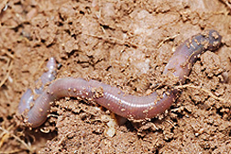 | 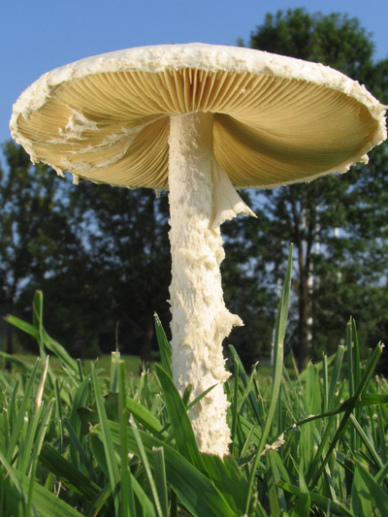 | 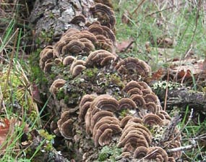
Soil  Mesofauna  10⁻⁵ to 10⁻³  (measured in millimeters) | 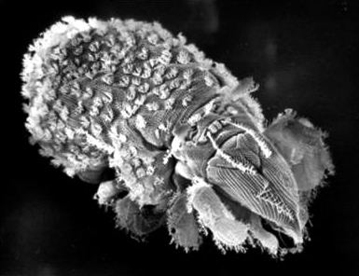 | 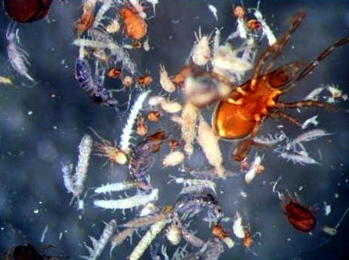 | 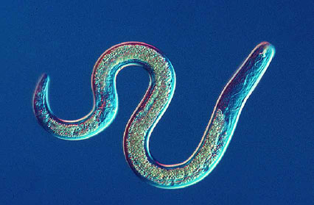
Soil  Microfauna  10⁻⁶ to 10⁻⁵  (measured in micrometers) | 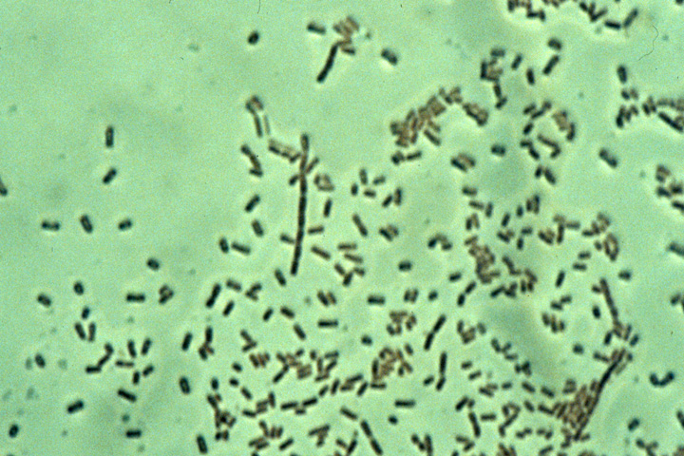 | 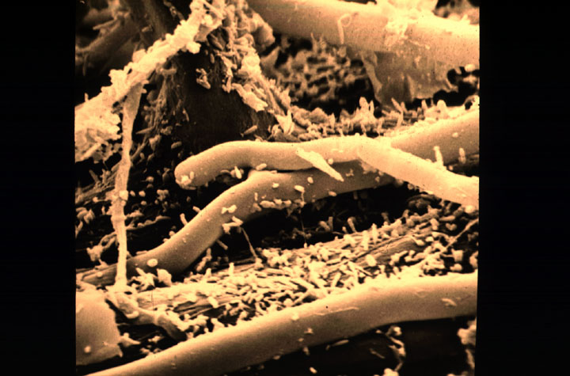 | 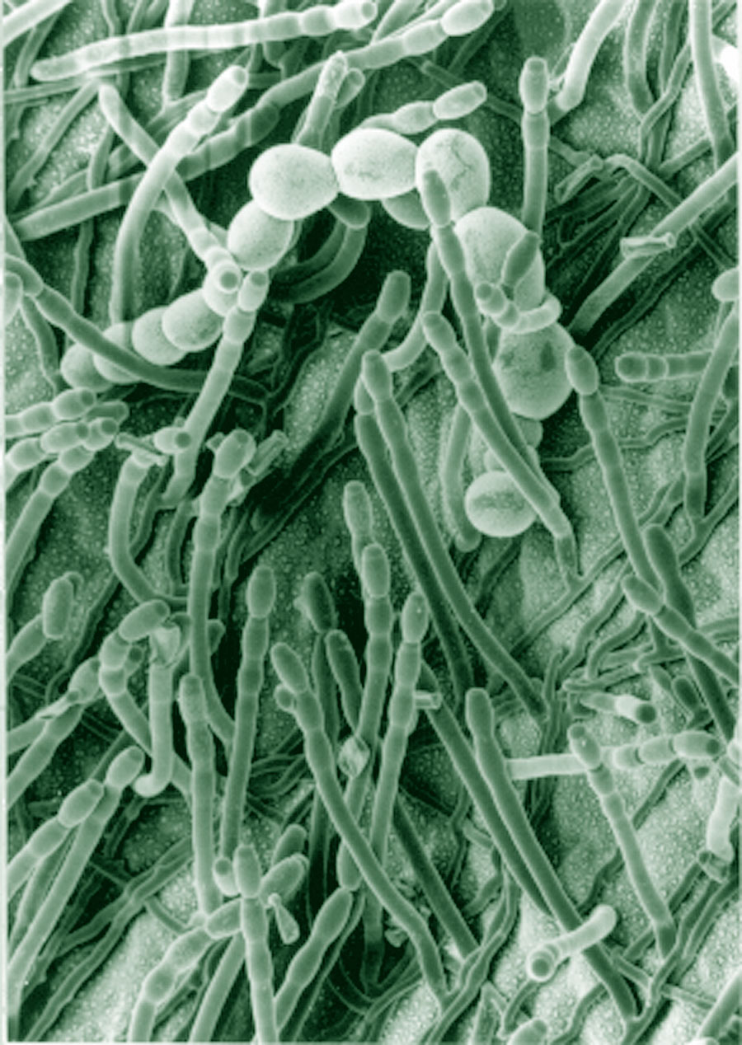

Core Lesson 3: Decomposer Growth

Time/Duration: 55 minutes
Activity 1: Speeding Up Decomposition ~15 minutes
Activity 2: Breaking and Building Molecules ~40 minutes

Guiding Question: When decomposers grow, where does all the stuff come from? And how does dead organic matter become part of the decomposers?

Model Response:
Alex | Blake | Carmen
Decomposers eat rotten food and the rotten food adds mass to the decomposers but a lot of the rotten food might evaporate or just go into the soil. | Decomposers use cellular respiration to grow. They eat dead organic matter and it’s used in the cells for energy and that’s how they gain mass. | Some of the dead organic matter digested by decomposers is rebuilt into polymers inside the decomposer’s cells. That’s how they grow.

Decomposer growth is very similar to growth in other organisms except that many decomposers digest their food on the outside of the body structure before the materials are then absorbed into the decomposer’s cells and either oxidized or rebuilt into polymers. As Carmen explains, the dead organic matter that is digested, or broken down, could become part of the decomposer’s body through biosynthesis (or rebuilding of polymers; Level 4). Like Carmen, Blake (Level 3) has a fairly sophisticated awareness of chemical change in decomposition, recognizing that decomposers undergo cellular respiration, but he overlooks the digestion and biosynthesis processes that help the decomposers grow. Alex (Level 2) sees that dead organic matter is a source of food for decomposers, and therefore the key source of mass, but has not yet learned how dead organic matter is chemically transformed during digestion and biosynthesis (instead focusing on physical change processes like evaporation or simply turning into soil).

Learning Objectives:
Students are now familiar with a number of different kinds of decomposers, both macro- and microscopic, and they know that these organisms are responsible for the decay of dead plants and animals. However, they still may not know how – or for what purpose – this is accomplished. This lesson uses time-lapse videos of decaying materials to help students visualize the role of decomposers in decay, and to notice that decomposer mass increases as the material on which they are growing decreases. Students will then think about how decaying matter (food) is broken down and incorporated into biomass through a modeling activity, and will make connections with other units, especially the unit on animals, to see that the same processes (digestion and biosynthesis) are taking place.

Rationale & Background:
Students may not be aware that decomposers are living things with the same matter and energy needs like other organisms. Decomposers need a steady supply of chemical energy, which they receive when they digest dead organic matter in their environment. Like animals, decomposers grow through several metabolic processes, including digestion, biosynthesis, and cellular respiration—the latter providing energy to drive other processes. It is through digestion and biosynthesis that decomposers are able to break down complex polymers in the dead organic matter they eat, which are later rebuilt into other polymers that help decomposers’ body structure to grow. However, unique to decomposers is the fact that for many, digestion happens on the outside of the decomposer’s body. Earthworms, for example, have internal digestive systems similar to other animals. But other decomposers, like some bacteria and fungi, actually use secretion of chemicals/enzymes to break down various polymers in the environment.

Lesson Description:
In this lesson, students observe several time-lapse videos depicting decomposer growth. Students consider where the mass of the decomposers comes from as they grow. Using a paperclip activity, students model the processes of digestion and biosynthesis to demonstrate how dead organic matter (and chemical energy in organic matter) become part of a decomposer’s body structure and stored chemical energy. The lesson concludes with using process diagrams to construct an account for how matter and energy change during decomposer growth.

Lesson Materials:
General
- Public space to record student ideas (board, projector, smart board, etc.)
- Decomposer PowerPoint
- Computer to project PowerPoint and videos
- Time-lapse video links (see Activity 1)
Per Partners
- Handout Building Organic Molecules
- Paperclip sets
  - 15 silver, 12 small gold, 8 black, 15 colorful
- Worksheet Fungus Growth: Digestion and Biosynthesis (2 parts)

Advance Prep:
- Have computer and PowerPoint ready to project.
- Assemble paperclip sets. Also, note that this activity is the same as the Animal Metabolism unit, so you may decide to eliminate it and focus on teaching key differences between digestion in decomposers and digestion in animals.

Activity 1: Speeding Up Decomposition

Time: 15 minutes

Rationale & Description:
In this activity students watch several time-lapse videos on decomposition. YouTube has a wealth of videos on decomposition and bacteria and fungi growth, many of which are time-lapse. Several video producers, such as WorldinslowmotionHD (a BBC program), have their videos available through YouTube, providing high quality options to show to students. Example videos you might use in this activity are included below, but you may find other videos that would serve the same purpose. The primary goal is for students to develop a visual image of decomposer growth (and increase in matter), which sets students up to discuss where this matter might come from and then move directly into working with digestion/biosynthesis paperclip modeling or moving on to the process diagram for decomposer growth.

Note: Keep in mind that YouTube videos sometimes contain ads at the beginning, and then also recommend related videos at the end. When showing “decomposition” videos this may pull up images of human decomposition, which could be disturbing to students. If that is the case, stop the video just before it ends to prevent YouTube from sharing additional related videos.

Fungi Growth Videos:
http://www.youtube.com/watch?v=SGQBgPbzums&feature=fvsr
http://www.youtube.com/watch?v=0VXdco-WzNA&feature=relmfu

Bacteria Growth Videos:
http://www.youtube.com/watch?v=y3TOZ_abECM
http://www.youtube.com/watch?v=eqrtNef7w38

General Decomposition video (turn narrator off or on)
http://www.youtube.com/watch?v=5kG18FYISaY

Directions:
- Ask students to think about what they’ve observed at home when mold grows on food. Where does this mold come from? Where does the mold get its mass? Allow students a couple of minutes to discuss possible sources of mass with their partner. Then have students share their ideas aloud. Make a list of student ideas on the board or overhead projector. Students likely will mention that mass must come from the rotting food, and this is possibly the only answer they will give, but they will probably harbor some belief that the mold simply grows out of “nothing”, so probe the students further about how the mass of the rotting food (like bread) becomes part of the decomposers. Spend at least 10 minutes discussing this question to see what your students think. This will give you good evidence about your students’ starting point for decomposer growth, especially what they know about digestion of dead organic matter. If you’ve completed the animal metabolism unit, you might begin to hear them applying a few things they learned in that unit to decomposition.
- Make sure the computer is ready to project the videos to the class. Show students 2-3 time-lapse videos of decomposers growing (seemingly from the ground, or rotten material, or agar plates; this last example can be compared to the Jell-O activity). Choose from the videos above or comparable ones you find online. After each video ask students about their observations. What did they see happening over time? Where did the decomposers come from, and specifically where are they getting their mass? The videos and discussion will set students up for learning more about digestion and biosynthesis in decomposers, and how they gain their overall matter and stored chemical energy.

Activity 2: Breaking and Building Molecules

Time: 30-40 minutes

Rationale & Description:
Depending on whether you have completed this activity in the Animal Metabolism unit you may choose to use it now, or simply use the PowerPoint process diagrams. In this activity, students use paperclips to model the breakdown (digestion) and rebuilding (biosynthesis) of polymers. The only true difference between animal digestion and biosynthesis and decomposer digestion and biosynthesis is that in animals these processes happen within the body system, while in many decomposers, digestion happens on the outside of the organism’s body.

Note: If you skip the paperclip activity you can use the time-lapse videos in the previous activities with the process diagram PowerPoint presentations in this activity. But you may want to cover the basics of digestion and biosynthesis in some way so students understand the key difference between decomposer and animal digestion.

Directions:
- To introduce the paperclip modeling activity, show a macroscopic handful of soil and zoom in to see the organic matter mixed in with inorganic matter (see Zooming into Soil PowerPoint slides 4 – 7).
- Using slides 4 and 5, show students macroscopic images of soil with leaf litter, which is at the 10⁻¹ scale. A handful of soil is roughly 1/10 of a meter on the Powers of Ten scale. The next slides zoom into the soil at the 10⁻⁸ scale so that students are looking at graphs of the composition of soil and the chemical structure of organic molecules. These molecules are almost a billion times smaller than the handful of soil itself. Take time to explain carbohydrates (like cellulose), proteins, and fats are examples of organic molecules, all of which are polymers made of smaller molecules called monomers. Carbohydrates are made of monomers of glucose. Fats are made of monomers of glycerol and fatty acids, and proteins are made of monomers called amino acids. All of these are composed mainly of carbon, hydrogen, and oxygen and are rich with chemical energy. Focus on cellulose as the example polymer and glucose as the example monomer. Use a single paperclip to represent a monomer and a chain of paperclips to represent polymers. Tell students that “mono” means one, while “poly” means many. Today students will build polymers that are in the organic matter of the soil and trace what happens to the polymers over time when they are digested and ingested by decomposers.
- Pass out paperclip packets and instruction handouts to pairs of students. The paperclip packet should include 15 silver paperclips, 12 gold paperclips, 8 black paperclips, and 15 colorful paperclips. Have students build these into polymers and monomers following the Building Organic Molecules instructions on their handout. They will have two starch, three protein, three fat, and two fiber/cellulose molecules, along with a couple extra monomers (glucose).
- Using the student handout, walk students through four different time periods and locations as the organic matter in the soil is digested. At each step they will work with their paperclips to mimic what is happening to the polymers through digestion and biosynthesis.
  - Early Digestion/Outside Decomposers: Students have built their basic polymers. These polymers have actually been broken down physically (by various environmental factors) and chemically by animals and larger decomposers, but they are still too large for decomposers, like bacteria and microscopic fungi, to absorb.
  - Secretion of Enzymes: This step in digestion is like the enzymes secreted in our mouths and stomachs to start the early digestion process in animals. These enzymes break down all polymers into partial chains and some loose monomers, like glucose, amino acids, and fatty acids.
  - Absorption: After enzymes have completely broken down polymers into monomers, they can be absorbed across the decomposers’ membranes, entering the decomposers’ bodies and traveling to cells (if multi-cellular). Pose the question, “Once all these monomers are inside the decomposers, what do you think happens to them?” Elicit students’ ideas about cells and what cells might do with these basic materials (students might bring up both cellular respiration or biosynthesis).
  - Cell: When monomers arrive inside the decomposers’ cell(s), they stay monomers until the cells are ready to re-build them into larger molecules (polymers), eventually making the cells larger and larger. The cells may then divide, and over time this results in visible decomposer growth that we can see with our eyes. Depending on your time and focus for the lesson you might consider making the connection to cell division at this time.
- At the end of the activity have students respond to the question: “When decomposers eat dead organic matter in soil, how does it become part of their bodies?” Save time for discussing this question aloud. This will give you a good sense of how much your students learned about digestion and biosynthesis through the modeling activity. Using the Decomposer PowerPoint: Decomposer Growth, construct an account for how the decomposers change matter and energy when they use organic matter in biosynthesis.

Building Organic Molecules

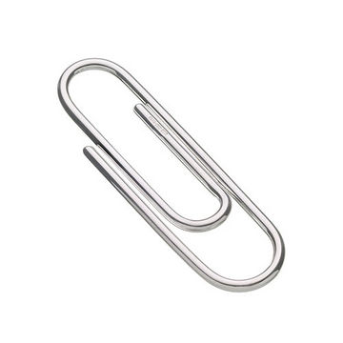
Starch Monomers Protein Monomers
(Silver) (Colorful)

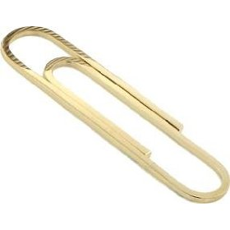
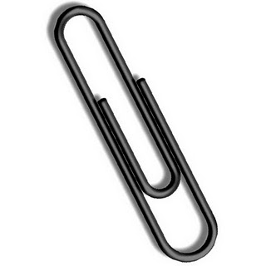
Fat Monomers Fiber Monomers
(Gold) (Black)

Use this information to build: 1) STARCH and FIBER polymers
2) LIPID polymers
3) PROTEIN polymers

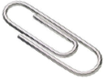
Step 1: Build a STARCH molecule by linking together 6 small, silver paperclips. Each silver paperclip represents a monomer (glucose), so starch is a chain of glucose molecules. Build two starch molecules using 12 of your silver paperclips. The extra silver paperclips represent sugar not part of a starch chain.

Step 2: Build a FAT molecule by three linking fat monomers. Link together 4 gold paperclips for each fat molecule. Make three chains total using all 12 gold paperclips.


Step 3: Build PROTEIN molecules by making chains of different protein monomers. Choose 5 different colors (red, yellow, blue, green, purple, etc) and link the colorful paperclips together. Each color represents a unique monomer and when combined in different ways you get different proteins. Make up to three protein molecules using your 15 colorful paperclips.

Step 4: One type of carbohydrate is fiber. Build a FIBER molecule by linking together 4 black paperclips. You will need to build two fiber molecules with your 8 black paperclips.

Name: _____________________ Period: ______ Date: _________

Worksheet with Commentary: Fungus Growth: Digestion and Biosynthesis
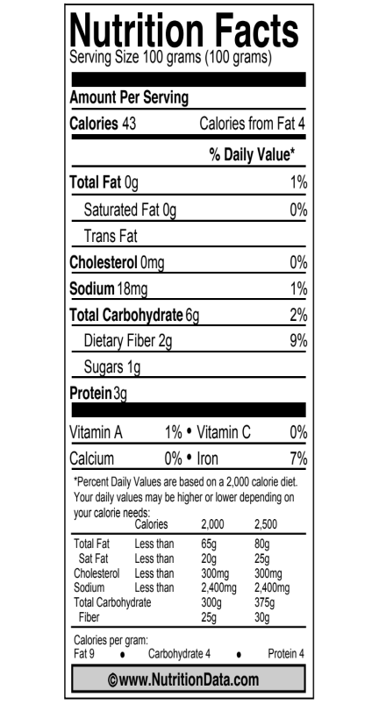
Before Viewing the PowerPoint
A mushroom is the fruiting body of a fungus (sort of like the apple on a tree). It spreads spores from the fungus to other places where it might grow. The main body of the fungus is called the mycelium; it is an underground network of thin fibers called hyphae.
The Nutrition Facts label at right shows some of the materials found in mushrooms. Look at the label and list some of the important materials in mushrooms.

Materials in mushrooms:
1. Carbohydrates (fiber, sugar)

2. Protein

3. Vitamins and minerals

4. Sodium
The fungus depends on dead plants and animals as a food source. List some of the materials that you would expect to find in dead plants and animals. (Hint: Can you find other nutrition labels that show the materials in dead plants and animals?)

Materials in dead plants and animals:
1. Depending on the labels used, students should include primarily carbohydrates, proteins, and fats.
2.

3.

4.

How do you think the mushroom fungus can make the materials in the mushroom out of the materials in dead plants and animals?
The students should make a prediction based on what they know from prior lessons and units. At this point they may concentrate on macroscopic changes (e.g., food helps cells get bigger/divide more) and will probably not consider microscopic/molecular changes.

Name: _____________________ Period: ______ Date: _________
Digestion and Biosynthesis: After Building Molecular models and Viewing the PowerPoint

Describe your revised ideas about how a fungus can transform materials in dead plants and animals into materials in a mushroom.

Location #1: Outside the hyphae
Explain what is happening to the large organic molecules in food outside the hyphae of the fungus.
Students should be able to explain that the fungus is breaking down large molecules into smaller monomers (may or may not refer to the secretion of enzymes by the fungus).

Use the process tool to show what happens to one material in grass. This is a “translation” task: Can they take the key words from their explanations and put them appropriately into the process tool diagram?

Location #2. Movement of materials to the mushroom
In order for the mushroom to grow, it must get materials from somewhere. Explain how the small organic molecules get to the mushroom—the fruiting body of the fungus.
Students should mention that the main body of the fungus, or mycelium, is composed of hyphae that transfer materials (monomers) absorbed from the soil to the fruiting body.

Location #3. Transformation of materials inside the mushroom cells
The mushroom cells are made of large organic molecules—especially protein and carbohydrates—as well as water and other materials. Explain how the mushroom cells make the large organic molecules as they grow.
Students should explain that the mushroom’s cells use the absorbed monomers to build polymers, making the cells grow larger and divide, resulting in growth.

Use the process tool to show what happens to one material in the mushroom is made. This is a “translation” task: Can they take the key words from their explanations and put them appropriately into the process tool diagram?

4. Checking your explanation
Does your explanation follow the principles that apply to chemical changes?
Yes No Not sure Conservation of matter: Materials (solids, liquids, or gases) change into other materials, but matter is not created or destroyed.
Yes No Not sure Conservation of mass: The masses of reactants and products are equal.
Yes No Not sure Conservation of energy: Energy is not created or destroyed.
Yes No Not sure Conservation of atoms: Atoms are not created or destroyed.
For these questions note the accuracy of their evaluations. If their explanation is not consistent with the principles, are they aware of it? How confident are they in applying the principles?

Core Lesson 4: Now You See It, Now You Don’t

Time/Duration: 75 minutes
Activity 1: Evidence of Mass Change In Decomposition ~15 minutes
Activity 2: The Air Around Decomposition ~30 minutes
Activity 3: Accounting For Results with CER ~30 minutes

Guiding Question: Can decomposers turn dead plants and animals into gases?

Model Response:
Alex | Blake | Carmen
No, decomposers may eat the dead plants and animals, but most of it turns into soil so that plants can use it for nutrients. | Decomposers might give off some gases from cellular respiration, but most of the dead plants and animals are turned into soil nutrients. | Decomposers turn most of the dead organic matter into carbon dioxide and water during cellular respiration. Only a little mass stays as nutrients in soil.

In order for decomposers to meet their energy needs, they are constantly digesting, and then oxidizing, organic matter. The chemical energy in the organic matter becomes usable energy for decomposers, but when this energy is transformed, the matter is also transformed as described by Carmen (Level 4). She explains correctly that the matter/mass of the dead organic matter is changed into gas products via cellular respiration. Understanding that solid organic matter becomes gases is a major step forward when compared to Blake’s explanation (Level 3). He is still hesitant to contribute matter/mass loss in organic matter to the air and focuses mostly on the solid-solid nutrient cycle. Alex (Level 2) does not believe that gases are a product of decomposition, although he may identify that certain things—an apple or watermelon for example—may give off gases through evaporation as they rot.

Learning Objectives:
Students will return to their Rotten Work investigation results to conclude that a significant amount of mass was lost from the Jell-O/decomposer plates. This lesson focuses on identifying where the mass might have gone if not in the cells of the decomposers.

Rationale & Background:
Up to this point in the unit students have focused on identifying decomposers and explaining decomposer mass gain through digestion and biosynthesis. This lesson turns students’ attention to the mass loss by the overall decomposing system and includes investigations to help students connect mass loss in decomposing systems to increased carbon dioxide in the air. The fact that dead organic matter eventually turns into carbon dioxide and water and is released to the air seems counterintuitive to most students, so they will need to observe decomposers actually changing the air around them in order to be convinced.

Lesson Description:
The activities in this lesson are intended to help students move toward an understanding of cellular respiration in decomposers, and to make a connection between mass changes in dead organic matter and increased CO₂ in the air. Students finish up their Rotten Work investigations and draw conclusions about the mass changes during decomposition using their results. Students then set up investigations to test the air around decomposers for any indication of increased CO₂ and water, as well as mass transfer from decomposing matter to gases (as indicated by soda lime mass gain). The lesson concludes with the construction of process diagrams to show how matter and energy transform as decomposers respire (with an optional reading about decomposition).

Lesson Materials:
General
- Decomposer PowerPoint: Cellular Respiration in Fungi
- Computer ready to project PowerPoint and video
- Time-lapse video links (see Activity 1)
Per Group
- Jell-O Decomposer samples
- Digital scale
- Cobalt chloride test strip (optional)
- 2 airtight Ziploc containers (or equivalent)
- 2 empty petri dishes
- 20-30g soda lime (can be completed as classroom demo)
- 50 mL BTB indicator (can be eliminated if CO₂ probe is used instead)
Per Student
- Worksheet Rotten Work Investigation and Investigating the Missing Mass (3 parts)
Optional
- Vernier CO₂ probe and interface or ability to project CO₂ probe video to class
- Vernier 2000mL respiration chamber

Advance Prep:
- Mix distilled H₂O and BTB in a flask (approximately 10:1).
- Have Jell-O-decomposer samples ready for final mass measurements today.
- You will need to make decisions about how you would like to conduct Activity 3, where students are measuring CO₂ concentration with probes OR using BTB and also where students are handling soda lime. You may decide to complete all investigations as demos, or you may choose to do the probe as a demo and allow students to set up the soda lime and BTB as small group labs. Keep in mind that you will want to set up “control” BTB and soda lime for comparison, but students do not necessarily need their own controls. Several modifications are presented in the Activity 2 instructions.

Activity 1: Evidence of Mass Change in Decomposition

Time: 15 minutes

Rationale & Description:
At the beginning of the unit students began Jell-O-decomposer investigations in the Rotten Work Investigation. Since that time students have seen evidence through secondary data sources and time-lapse video indicating that matter is moving out of dead organic matter and into decomposers and soil, but far more of the matter is simply not accounted for by gains in soil or decomposer mass. In this activity, students will take final mass measurements of their Rotten Work Investigations and share their findings aloud.

Directions:
- Have a computer ready to project videos. Show students 1 or 2 YouTube videos of decomposing food. When selecting videos you may use the ones below, or choose your own, but importantly, they need to show organic matter seemingly disappearing over time. Example videos:
  - http://www.youtube.com/watch?v=c0En-_BVbGc
  - http://www.youtube.com/watch?v=S12zZhdOckc
- Pose the following question to students: “Where does MOST of the mass of the decaying matter go?” Ask students to vote on one of the following choices:
- It turns into soil (or solid/liquid wastes)
- It turns into gases (you may want to distinguish between evaporation and chemical change here)
- It turns into energy
- It disappears
- Other: ________________________
- Record the vote in a public space. Ask at least one student for each choice to share why they think their choice is the best explanation.
- Divide students into their Rotten Work Investigation groups. Have groups of students gather their lab materials, which are a digital scale and their Jell-O samples. Students will also need their Rotten Work Investigation sheets and a calculator. Using the lab investigation, have students spend about 5 minutes making final mass readings on their samples and calculating overall mass change. Students will also need to record observations of visible growth of decomposers.
- Have students share their results aloud and record each group’s results in a public space so students can see the emerging pattern across all Jell-O samples—an overall decrease in mass even though decomposers grew. Ask them to think about how they can account for this loss in mass of the overall system.
- Ask students to share their ideas, and then pose the question, “Well, if not into the Jell-O or the soil or the decomposers, where is the majority of the mass going? Did it disappear? Could it go into the air?”

Activity 2: The Air Around Decomposition

Time: 30+ minutes

Rationale & Description:
In this activity students will test whether the mass of decomposing organic matter is being given off as gases to the air—namely as carbon dioxide. This activity can be completed as a demonstration only, or a combination of demonstration and small group work. The proposed activity below uses the Vernier CO₂ probe as a demonstration (although this demonstration is not necessary if equipment is not available). The remainder consists of small group lab investigations where students seal their Jell-O/decomposer samples in airtight containers either with a BTB indicator or with soda lime (but not in the same container together). The BTB can be used as an indication that CO₂ is increasing in the air around decomposition. The soda lime, which absorbs water and CO₂, can show that while the decomposing system loses mass, the soda lime gains mass (more than can be explain by water and CO₂ in the existing air).

SAFETY NOTE: Soda lime is caustic and a major irritant if inhaled or if it enters the eyes. Students should wear gloves and goggles when handling soda lime. If gloves and goggles are not available you will want to distribute soda lime to students yourself, making sure you are the only one handling the soda lime as it is being massed and placed into or taken out of the containers.

NOTE ABOUT BTB PREPARATION:
Mix distilled H₂O and BTB in a flask (approximately 10:1). The BTB solution needs to be a bluish-green color because the CO₂ from decomposition for a 24-hour period may not be great enough to show color change in your standard BTB solution. To produce BTB that will show color change with more certainty, you can take your solution and either swirl it in a flask (to mix with air) until color is bluish-green, or you can use a straw to blow lightly into BTB solution (very lightly) until color lightens to a bluish-green. This should help ensure that students will see a change from blue/green to yellow over the course of a 24-hour period.

SPECIAL NOTE ABOUT CONTROLS: When doing labs with soda lime and BTB it may be important to have a “control” set of both materials running as students’ investigations are running. You can have one set of controls that all students share. Students do not need to set up their own controls. The controls will tell you how much CO₂ (and water) is absorbed from the typical surrounding air without the addition of the decomposers. Using the same containers that students use, simply mass a sample of soda lime and seal inside the empty container. Place a sample of BTB (from the same BTB used by students) into a separate container. When students make their final mass readings and color observations, make sure to mass the control soda lime and note the color of the control BTB as comparisons to students’ results.

Directions:
Vernier CO₂ probe procedures:
- If you have access to a Vernier CO₂ probe you can use the probe to measure CO₂ concentration around the Jell-O-decomposer samples. Note that you can also measure O₂ levels if you have the O₂ gas sensor as well.
- Prepare the probes and software for data collection.
- Insert a well-developed mold-Jell-O sample into the Vernier 2000mL chamber. Attach the CO₂ probe (and O₂ probe) and seal the chamber completely using parafilm tape. Wait 1 minute and then begin data collection. Collect data for up to 10 minutes, projecting the real-time data and graph for students to view.
- Pose the following question to the class, “Where is all the extra CO₂ coming from?” Note that you can modify the lab investigation sheet below if you would like students to record results from the probe demonstration and/or write explanations about what they observed.

Soda Lime and BTB Small Group Lab
- Pass out the investigation sheet The Air Around Decomposition. Note that you can modify this lab investigation sheet if you conduct the Vernier CO₂ probe demonstration above.
- The investigation sheet includes two quick investigations students will carry out with their well-developed Jell-O decomposer samples. Students need to gather a few additional materials (following any safety precautions for soda lime and BTB) and then follow the procedures for setting up their systems. These investigations should run over 24 hours, so students will be ready to make observations and record results on the following day.
- All investigations will need to be in sealed containers for BTB and soda lime separately and placed in a location where they will not be disturbed overnight. After 24 hours students will need to measure the mass of their Jell-O-decomposers and soda lime, and note the color change for the BTB.
- Have students share their results aloud and record these in a public space for students to observe patterns across the data. In the soda lime experiment chamber, students should see that Jell-O/decomposers continued to lose mass, mass of soda lime increased. In the BTB experiment chamber, students should observe a BTB changed from blue to yellow. If you used a control set of soda lime and BTB, make sure to discuss that air in the container already had some CO₂ and water, thus, the BTB and soda lime absorbed some of these gases but not to the degree observed in the Jell-O decomposer systems.
- Pose the following question to students: “If dead organic matter doesn’t go into soil/Jell-O or decomposers, could it go into the air?” Give students time to write down their ideas and discuss the question in groups, or as a whole group.

NOTE: This is an excellent opportunity to use the Cobalt Chloride strips to test for water products from decomposition. Moisture may collect on the inside of the petri dish lids. If you choose to do this activity, make sure each group has 1 or more cobalt chloride test strips to make this observation.

Activity 3: Accounting For Results with Claims, Evidence, and Reasoning

Time: 30 minutes

Rational & Description:
Students have just completed their investigations and found two patterns: 1) the Jell-O/decomposer systems gave off a measurable amount of CO₂, and 2) the systems lost mass while the mass of soda lime (which absorbs CO₂ and water) increased, and the BTB changed color, indicating the presence of CO₂. This activity asks students to explain how reactants are changing into products during decomposition to account for the “missing mass” of the original Rotten Work investigation.

Directions:
- Ask students to revisit their initial explanation and prediction. Now that they have more information about materials present in the Jell-O/decomposer system, how would they revise their explanation? Students should use the process tool to incorporate the new findings and develop their explanations. On the backside of students’ worksheet, they have questions about their claims about decomposition, their evidence, and their reasoning. Allow students to work in their groups to answer these questions. Students may need 15 minutes to do this.
- Students will indicate the observations and measurements on which the evidence for their revised explanation is based, and then explain how the evidence supports their claim. They should be able to reason that because decomposers are known to give off CO₂, this gas must account for at least some of the missing mass, and that something is happening after the decomposers ingest the gelatin so that the portion not converted to biomass is released to the air. The next lesson will introduce students to the idea of cellular respiration and help them to explain how this might happen.
Name:_____________________ Period:____ Date:_________

Worksheet with Commentary: Investigating the Missing Mass
Initial Explanation and Prediction
In chemical changes reactants (materials that are in the system before the change) always change into products (materials that the reactants change into). When the mass of the reactants in a chemical change doesn’t equal the mass of the products, there must be some material that we aren’t measuring properly.
In this investigation you will leave mealworms without food for a day or so, so you will have to figure out what the reactants and products are when mealworms are moving around, but not eating or growing. What materials do you think that the mealworms are using as energy sources for their movement? How are those materials changing?
Your explanation: How are reactants changing into products when mealworms move?
It is not important for students’ explanations to be correct at this point. Their explanations will give you a chance to evaluate their levels of reasoning:
- Do the explanations focus on actions and events more than matter and energy (Level 2)?
- Do the explanations focus on matter and energy, but with problems such as matter-energy conversion (Level 3)?
- We generally would not expect students at this point to successfully trace matter and energy (Level 4)
Your prediction: What changes in reactants or products could we measure or observe?
A key thing to look for here is whether they can make predications that match their explanations.

Using the Process Tool to show your explanation and prediction: Show your ideas about how matter and energy change when mealworms grow on the process tool diagram below. This is a “translation” task: Can they take the key words from their explanations and put them appropriately into the process tool diagram?
Name:_____________________ Period:____ Date:_________
The Air Around Decomposition: Measurements During the Investigation

In these investigations you will test whether CO₂ and water vapor are given off from decomposition. You will need to gather a few additional materials to set-up your investigations, and carefully follow the procedures below.
Investigation #1: Test for Carbon Dioxide with BTB
Data:
 | Starting Color | Ending Color
COLOR of BTB Solution

Investigation #2: Test Carbon Dioxide with Soda Lime
Data:
 | Start Mass | End Mass/ | Mass Change
MASS of Jell-O-Decomposer Sample
MASS of Soda Lime

Results
Briefly summarize the main patterns that you saw:
What gained mass during your investigation?
Soda lime gained mass

What lost mass during your investigation?
Jell-O/decomposer system lost mass

Explaining Your Results
Claims—your revised explanation: How are reactants changing into products when mold grows on Jell-O?
As with their initial explanations, it is not essential that their explanations be correct at this point. You should check to see if they have modified their explanations to be consistent with the evidence that they have collected.

Using the Process Tool: Show your new ideas about how reactants changed into products on the process tool diagram below. Again, the key question here is whether the process tool is consistent with their written explanations.
Evidence—the measurements that support your explanation: What are the key observations and measurements that support your explanation?
The key question here is how well they select and summarize the evidence that is relevant to their claims.
Reasoning—connecting claims to evidence and scientific principles
Connecting explanations and evidence: How does the evidence support your explanation?
The key question here is whether they connect claims and evidence. Do they consider possible negative as well as positive evidence?
Connecting evidence and principles. Does your explanation follow the principles that apply to chemical changes?
Yes No Not sure Conservation of matter: Materials (solids, liquids, or gases change into other materials, but matter is not created or destroyed.
Yes No Not sure Conservation of mass: The masses of reactants and products are equal.
Yes No Not sure Conservation of energy: Energy is not created or destroyed.
Yes No Not sure Conservation of atoms: Atoms are not created or destroyed.
For these questions note the accuracy of their evaluations. If their explanation is not consistent with the principles, are they aware of it? How confident are they in applying the principles?

Core Lesson 5: Modeling how Decomposers get Energy for Growth and Functioning

Time/Duration: 110 minutes
Activity 1: What is Decomposition? ~30 minutes
Activity 2: Modeling Decomposer Respiration ~25 minutes
Optional Activity: Soil Flux Investigation ~55 minutes

Guiding Question: When a dead plant or animal decays, its mass decreases. How is the mass lost, and what happens to it?

Model Response:
Alex | Blake | Carmen
The dead organism breaks down and turns into soil and nutrients for other organisms. | Decomposers eat the dead plant or animal and turn it into energy during cellular respiration. | The dead plant or animal is food for decomposers, and is used in cellular respiration for chemical energy and given off as CO₂ and H₂O to the air.

Dead plants and animals are a source of chemical energy for decomposers. Through cellular respiration, this organic matter is oxidized and given off as CO₂ and H₂O (so that chemical energy can be transformed into usable energy for the decomposers). Carmen explains that when decomposers consume dead organic material, it is given off as gases to the air. This is what we hope students would explain after learning about cellular respiration (Level 4). Blake’s response, however, is more typical of students who learn about cellular respiration, explaining that through chemical processes and at the microscopic & atomic-molecular scale matter is changed into energy (Level 3). Sometimes students even believe that ATP is a form of energy as opposed to a form of matter. Alex (Level 2) will trace the lost mass with macroscopic indicators of matter changes—namely particles and nutrients that are returned to the soil.

Learning Objectives:
Students need to see that decaying matter is food for decomposers and is used by them in cellular respiration. There are numerous macroscopic indicators that decomposition changes matter and energy through respiration (e.g., decomposer growth, release of CO₂ and heat, etc.); students need to learn that all the macroscopic indicators relate back to atomic-molecular transformations.

Rationale & Background:
All living things, including decomposers, obtain the energy they need to function through the rearrangement of atoms during metabolic processes. This is the sole purpose of cellular respiration in all living organisms. Every living organism, from the smallest bacteria to the largest tree in the forest, needs to acquire a source of chemical energy, which is found in organic matter. Once organic matter is oxidized, the chemical energy found in the high-energy bonds is transformed into kinetic energy and heat. The atoms once tied up in organic molecules are rearranged into inorganic water and carbon dioxide. Cellular respiration helps to explain why the process of decomposition releases CO₂ and water, and why a compost pile gives off heat. Unfortunately, students primarily see cellular respiration as the way we convert food or stored biomass (fat) into energy to move and exercise. Students even make these matter-energy conversions at the atomic-molecular scale when they learn about ATP (another organic molecule). Students need to develop an explanation of cellular respiration that conserves both matter and energy, and makes the connection between atomic-molecular transformations and macroscopic observations.

Lesson Description:
In this lesson students read about decomposition and how it is connected to cellular respiration. Students learn that decaying matter is oxidized in decomposers’ cells and changed to gases, which explains where the matter goes when organic material decays. Then students model cellular respiration to see that organic materials with chemical energy are changed into inorganic water and carbon dioxide. The lesson concludes with a construction of the process tool for cellular respiration. The suggested optional activity will allow students to confirm that there are indeed microscopic decomposers present in soil and that they are performing both digestion and cellular respiration.

Lesson Materials:
General
- Decomposer PowerPoint
- Computer ready to project PowerPoint
- Soil samples
- Sugar and starch solutions
- Respiration chambers
- Vernier CO₂ probe

Per Group
- Molecular model kits
- Reading What is Decomposition?
- Handout Modeling Decomposer Respiration Instructions
- Handout Sample Data: Modeling Decomposer Respiration
- Handout Evidence of Decomposers Living in Soil
Per Student
- Worksheet Changing Dead Plants and Animals to Gases

Activity 1: What Is Decomposition?

Time: 30 minutes

Rationale & Description:
Depending on whether you’ve extensively covered cellular respiration in other metabolism units this may be a good opportunity to introduce a scientific explanation about cellular respiration. There are numerous ways to introduce this explanation to students, and you may have other activities—readings, PowerPoint presentations, or investigations—that you would like to use to present the scientific explanation to your students. The proposed activity below uses a PowerPoint series with the process diagram to zoom into decomposition at different scales. There is also a one-page reading about decomposition that could be used with the PowerPoint. Depending on the level of detail you would like to present to students, make modifications to the reading as you see fit.

Directions:
- If you choose to use the reading, you might consider using this resource first. Pass out the one-page reading What Is Decomposition? to each student. The reading can be collected and reused in other classes. Read through the page together as a whole class, stopping at various points to probe students’ thinking. See information about the reading below for suggested stopping points and discussion questions.
- Display the Decomposer PowerPoint. This PowerPoint includes process diagrams for cellular respiration in decomposers (fungi) at the micro scale and atomic-molecular scale. You may choose to integrate this PowerPoint with the reading, or use the PowerPoint on its own.
- After constructing process diagrams for decomposition, discuss the following questions with students:
  - How is the process of decomposition similar to what animals do with food?
  - How is this explanation for decomposition supported by evidence? Is there anything about the explanation that is still questionable to you?

Information About Decomposition Reading
The Decomposition reading provides very basic information about matter and energy transformations during decomposition/cellular respiration. Stop at various points to discuss the information with your students. For example, the following could be stopping points for discussion:
- After the first paragraph point students back to their Jell-O-Decomposer results. Ask students how the evidence they collected supports what they just read.
- The first two images on the page connect macroscopic and microscopic scales for decomposers. You can use this opportunity to locate each on the Powers of Ten chart.
- As students read about organic matter, like bread (or Jell-O, or plants, etc.), consider having nutrition labels for the substances as additional resources to discuss what makes the materials organic. Bread is composed mainly of carbohydrates, similar to the sugar in the Jell-O investigations.
- As students read about carbon dioxide and water waste products, stop to ask what evidence they’ve seen that supports the claim that these two gases are waste products from decomposition.
- The next paragraph specifically discusses energy transformation from chemical energy to kinetic energy and ultimately heat. Take time to discuss the heat given off by compost piles (and the photographs in the reading). Consider showing students additional infrared images of compost piles. Infrared images show that decaying matter gives off heat just like living organisms.
- The last paragraph asks students to apply what they read about bread mold to what happens on the forest floor. Elicit students’ ideas in response to this question.

Activity 2: Modeling Decomposer Respiration

Time: 25-30 minutes

Rationale & Description:
Depending on whether students have already modeled cellular respiration, this activity may be useful in combination with process diagrams for decomposition. In this activity students use molecular model kits to demonstrate chemical change from solid organic matter to gas products (and from C-C and C-H bonds to low-energy bonds). Molecular model kits allow students to physically rearrange atoms from reactants to products to show conservation of matter (atoms). This rearrangement of atoms also gives students a visual for where carbon atoms go in decomposition, as well as how energy changes from chemical energy to other forms of energy.

Activity Materials:
Per Group
- Molecular model kits (6 carbons, 12 hydrogen, 18 oxygen, & bonds)
- Handout Modeling Decomposer Respiration Instructions
Per Student
- Worksheet Changing Dead Plants and Animals to Gases

Advance Prep:
- Assemble molecular model kits, ensuring kits have at least 18 oxygen (most standard kits come with fewer than this).

Directions:
- Pass out model kits to groups of 2-3 students along with Modeling Decomposer Respiration Instructions. Students will first build glucose and oxygen molecules, answering questions about the type of atoms and bonds on their worksheet Changing Dead Plants and Animals to Gases. They will then rearrange these reactants into carbon dioxide and water. They need to be aware that matter is conserved and that chemical energy in the glucose is transformed into usable energy, like kinetic energy (and heat waste).
- Demonstrate for students how to use the molecular model kits. Then, as a class, build glucose and oxygen molecules. Use your display set if students need a visual.
- Have students respond to questions on their handout. Make sure to point out that glucose is energy-rich, organic matter reacted with inorganic oxygen. This is a monomer that is oxidized after decomposers have digested polymers.
- Next have groups break apart their molecules following the instructions and begin to build carbon dioxide and water.
- Give students time to complete their worksheet, pointing out that carbon dioxide and water are now inorganic materials and not a source of chemical energy, so the energy must have gone somewhere.
- Discuss the two questions on the student worksheet to conclude the activity.
  - Suppose you heard someone claim that leaves that fall from trees are eventually changed to gases that go into the air. Explain how this might be correct or incorrect.
  - You modeled that decomposers do cellular respiration. Explain how this is similar or different from what other living things do to get energy.

Optional Activity: Soil Flux Investigation

Time: 45-55 minutes

Rationale & Description:
Do decomposers live in soil? Or even sand? And if so, how does human impact on the soil change decomposer activity? This activity gives students with a solid foundational understanding of decomposition (Level 3 and Level 4 students) the opportunity to observe the products of respiration of soil microbes before and after treatment with a nutrient source. The investigation provides a comparison of two or more different types of soil that can be chosen by the teacher to show differences between plots of land (fertilized vs. non-fertilized, non-fertilized vs. compost vs. sand). The investigation can also show how the addition of sugar-based additives influence respiration rates compared to the addition of larger molecules additives (like starch). This will connect back to the process of digestion in decomposers, as well.

Activity Materials:
CO₂ Probe Demonstration
- 1-2 Vernier CO₂ probe and Go-Link interfaces
- Computer to project data collection
- Several respiration chambers that connect to probes or Ziploc baggies
- Soil Samples: 1 cup of various soil samples depending on purpose (examples: beach sand, yard soil, undisturbed forest soil, fertilized landscaping mulch, etc.).
- Additive solutions: sugar solution and starch solution; also consider fertilizer solutions (but note that these tend to have sugar in them).
- Spray bottles for each solution above

Advance Prep:
- Sugar solution: made with warm tap water and enough sugar until saturated (or at least 1 Tbsp. sugar per pint (16 oz.) water)
- Starch solution: if using starch as one of your variables as food for soil microbes, mix cornstarch and warm water until saturated (OR use water left over from cooking noodles)

Directions:
- For each type of soil, make 3 bags or 3 chambers by measuring out 50 ml (by volume) of soil. Label soil type (sand, soil, forest or from the location from which it came) on the bag or chamber. In addition, label one bag the control, the second sugar, and the third bag label starch. Do not seal bags.
- Take a “starting CO2” reading from inside all soil samples that are going to be the “control group”. To do this, zip the baggie shut or seal the chamber with a CO2 probe. The cord of the probe will extend from the baggie if Ziplocs are used. Collect data on the default settings for at least 4-5 minutes. Repeat for each control soil sample.
- Group together all soil samples that are going to receive sugar water. Take a CO2 reading from inside the bags/chambers. Record starting CO₂ levels in data table. Then squirt the sugar water solution into the soil 5 times. Shake bag/chamber just a little to ensure mixing of soil and sugar water. Zip each bag shut or seal chamber. Take a CO₂ reading from inside for at least 8-10 minutes. Record final CO₂ level in data table.
- Group together all soil samples that are going to receive starch water. Take a CO₂ reading from inside the bags/chambers. Record starting CO2 levels in data table. Then squirt the starch water solution into the soil 5 times. Shake bag/chamber just a little to ensure mixing of soil and starch water. Zip each bag shut. Take a CO₂ reading from inside the bags/chambers for at least 10 minutes. Record final CO₂ level in data table.
- Note that starch and sugar show really interesting patterns when CO₂ levels are recorded over 30 or 60 minutes or longer. If you can make these recordings your students might find these patterns interesting, especially in a discussion of the time it takes to break down starch through digestion. If you do not have this time, consider producing a data table that students can examine in addition to the data they do collect (like in the handout).

What Is Decomposition?

You’ve learned a lot about decomposers. You’ve learned that they grow on organic matter like dead plants and animals and that they eat the organic matter to grow and function. Decomposers gain their mass when they do this, but a lot of the mass of dead organic matter doesn’t become part of the decomposers, and it doesn’t go into the soil, so where does it go?
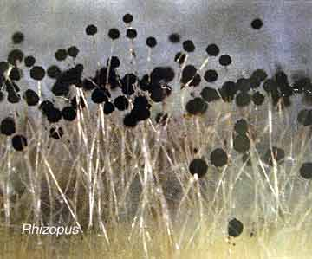
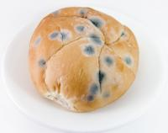

Macroscopic Scale (10⁻¹)
Microscopic Scale (10⁻⁴)

The photographs above show mold that you see with your eyes, and what that mold looks like under a microscope. In order for this mold to stay alive, it needs to have a source of chemical energy. Organic matter, like the bread, provides chemical energy for the mold cells to function. The mold cells also need oxygen so they can get the energy from the high-energy bonds in the bread. The mold cells react oxygen with the organic matter that makes up the bread. When they do this, the atoms are rearranged into carbon dioxide and water molecules. The chemical energy that was once in the organic matter of the bread turns into usable energy for the mold, like kinetic energy and heat. Does this process sound familiar? This is the process of cellular respiration, which all living organisms undergo to keep their cells functioning!
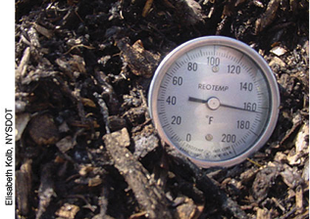
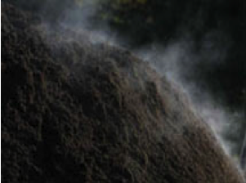
When chemical energy in organic matter is transformed into heat, decomposing compost can reach temperatures above 160°F. Look at the thermometer reading of this compost pile!

Similar to mold growing on bread, there are decomposers eating away at the organic matter that is left when plants and animals die in a forest. Using the explanation above, talk with your partners about what happens to the matter and energy when decomposers work away at the dead organic matter on the forest floor.

Modeling Decomposer Respiration Instructions

In your groups, you will use molecular model kits to model the process of cellular respiration in decomposers. You will build the materials that go into the decomposer’s cells, and then use the models to show how those materials change inside cells. The equation for cellular respiration is:
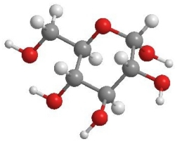

MATTER: Glucose (C₆H₁₂O₆) + 6Oxygen(O₂) → 6Carbon Dioxide(CO₂) + 6Water (H₂O)

ENERGY: chemical energy → kinetic energy + heat

This means that a glucose molecule is reacted with 6 oxygen molecules to form 6 carbon dioxide molecules and 6 water molecules. In order to model cellular respiration, you will first need to build your glucose and oxygen molecules.
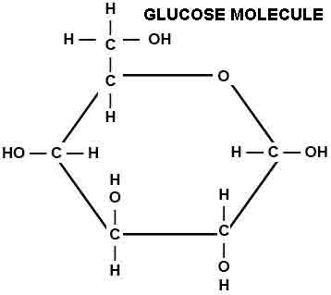
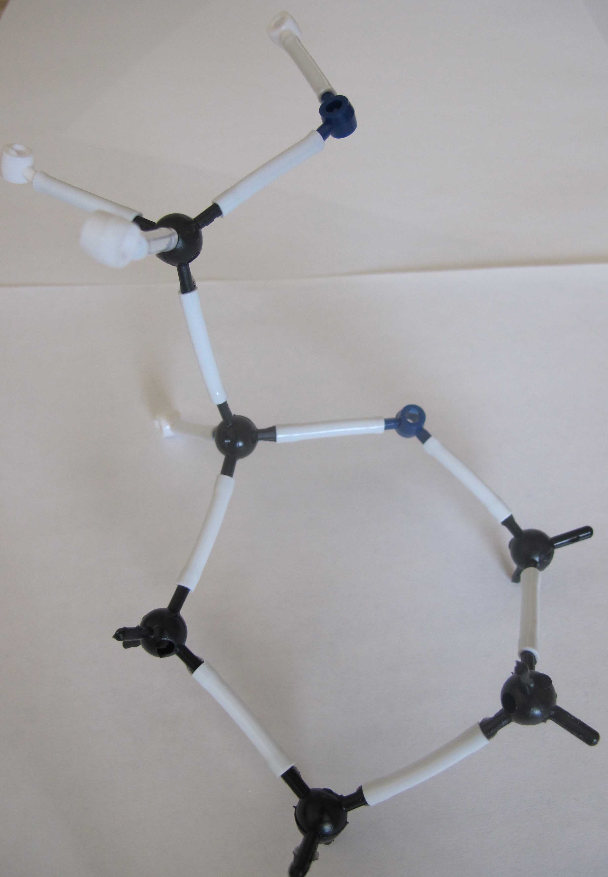
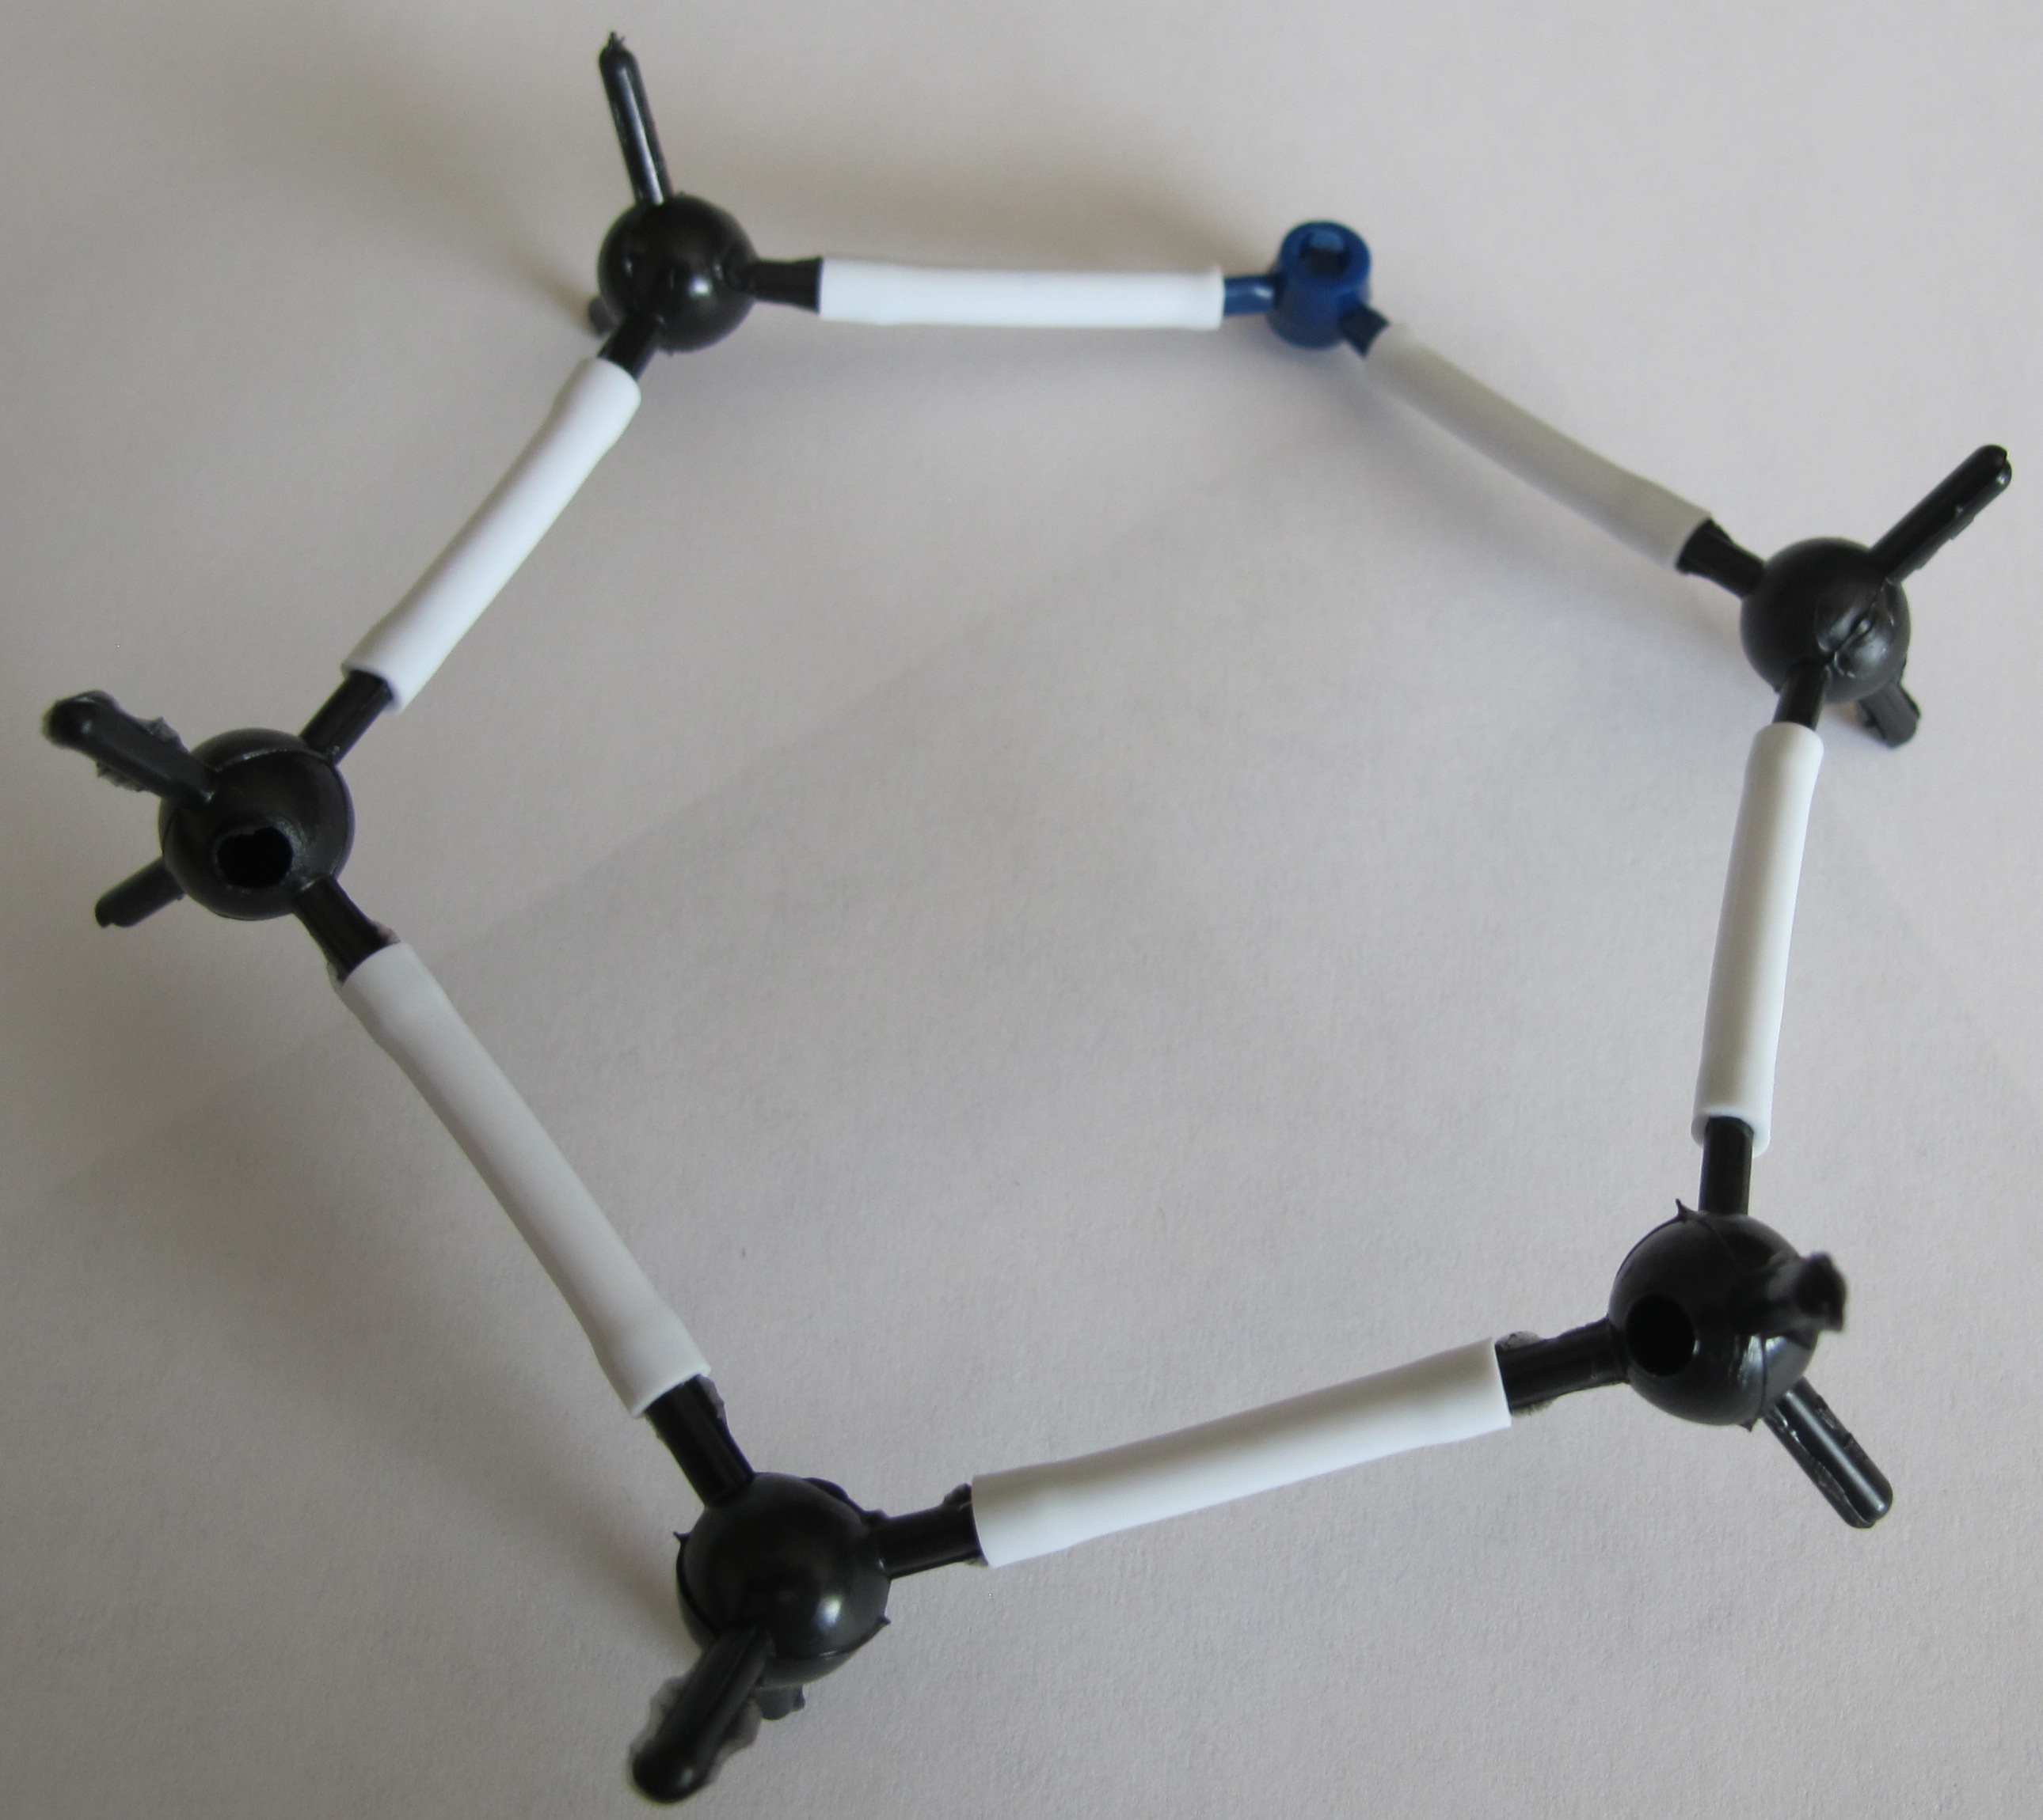
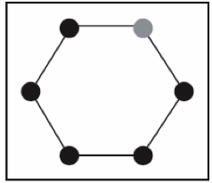
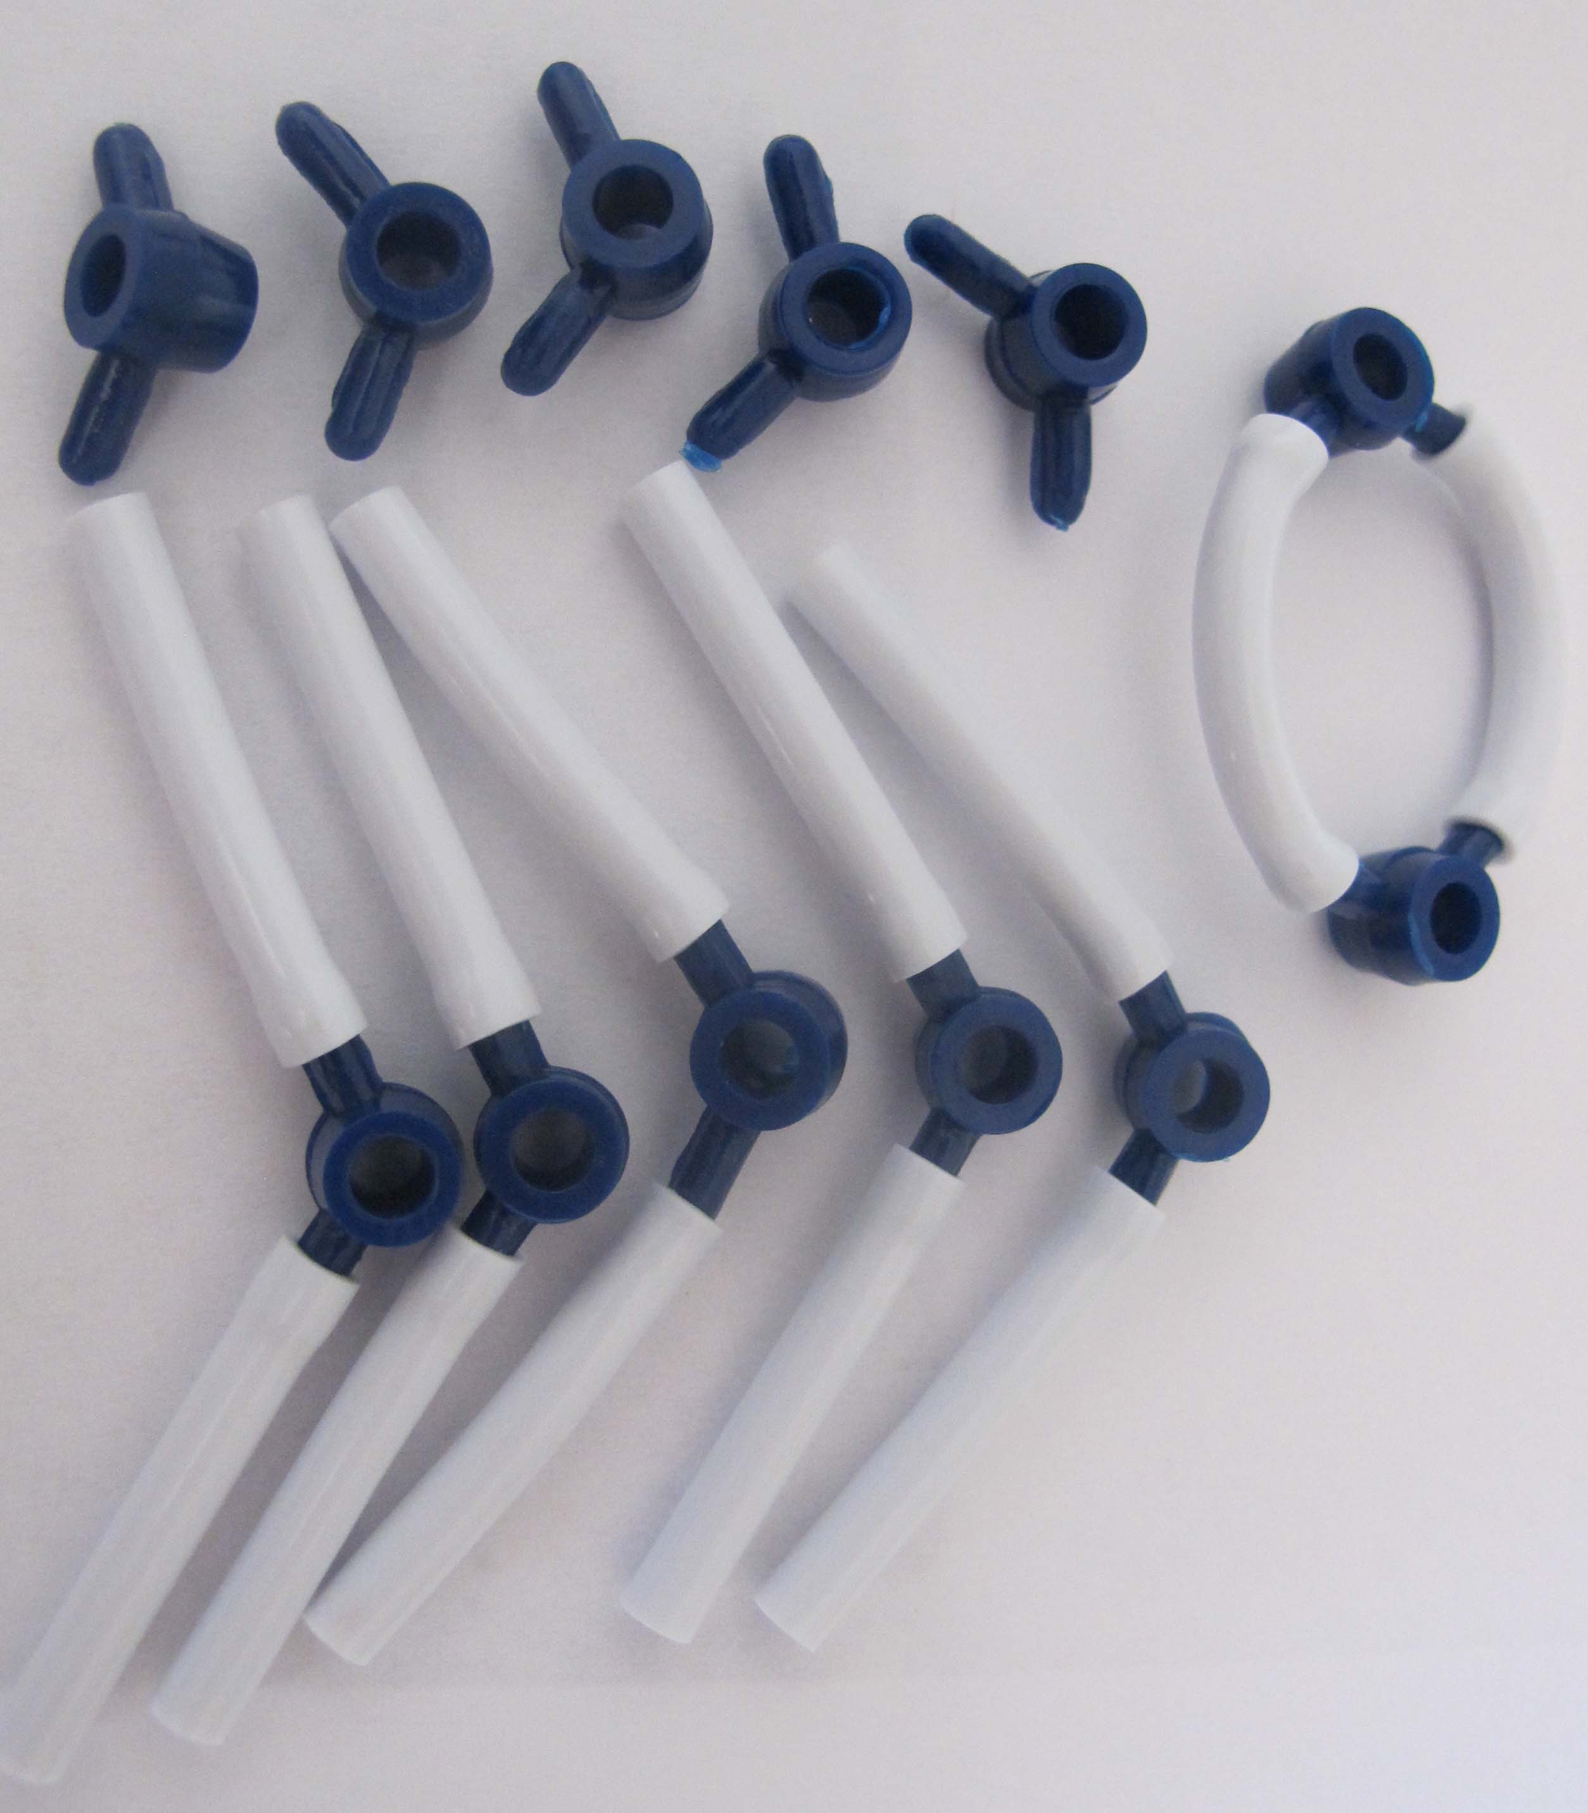
Step 1: Make Your Oxygen Molecules: Assign one person in your group to start working on the oxygen molecules. This person will need to make 6 oxygen molecules. Oxygen is 2 oxygen atoms connected using a double bond.

Step 2: Make Your Glucose Molecule: The rest of the group should work on the glucose molecule. First make the “glucose ring”, which is made of 5 carbon atoms and 1 oxygen atom connected to form a circular shape.

Next you will add the CH₂OH group. You will work with the carbon that is to the left of the oxygen in your ring. On this carbon, connect a second carbon. On the second carbon, attach 2 hydrogen and 1 oxygen atom. Attach another hydrogen to the oxygen. Then attach 1 hydrogen to the carbon that is on the ring.
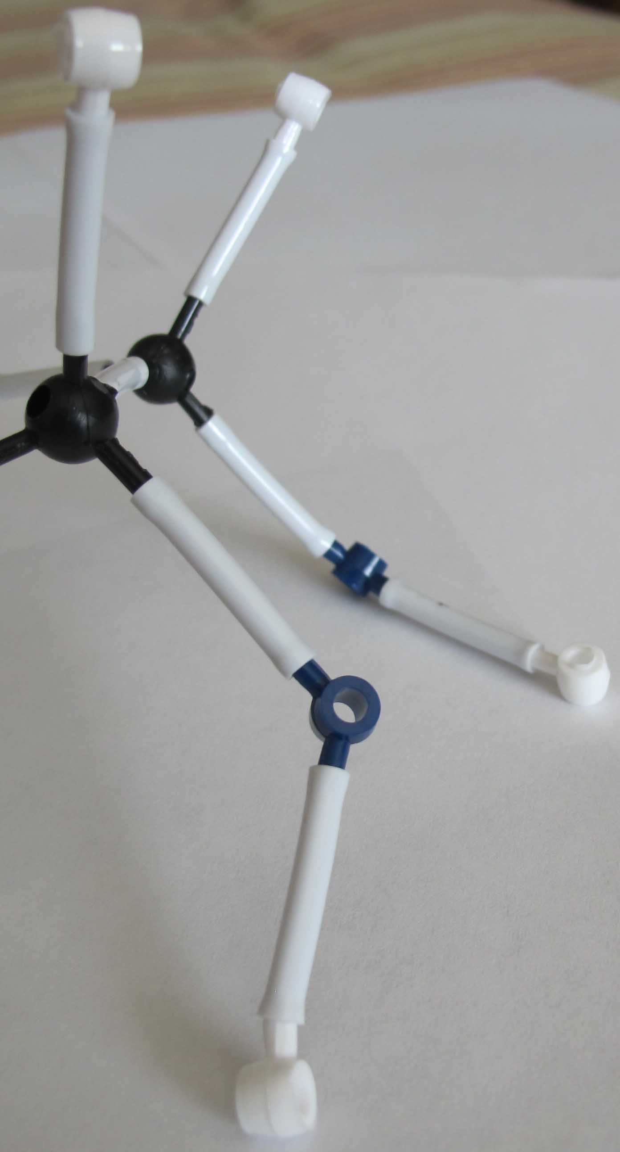
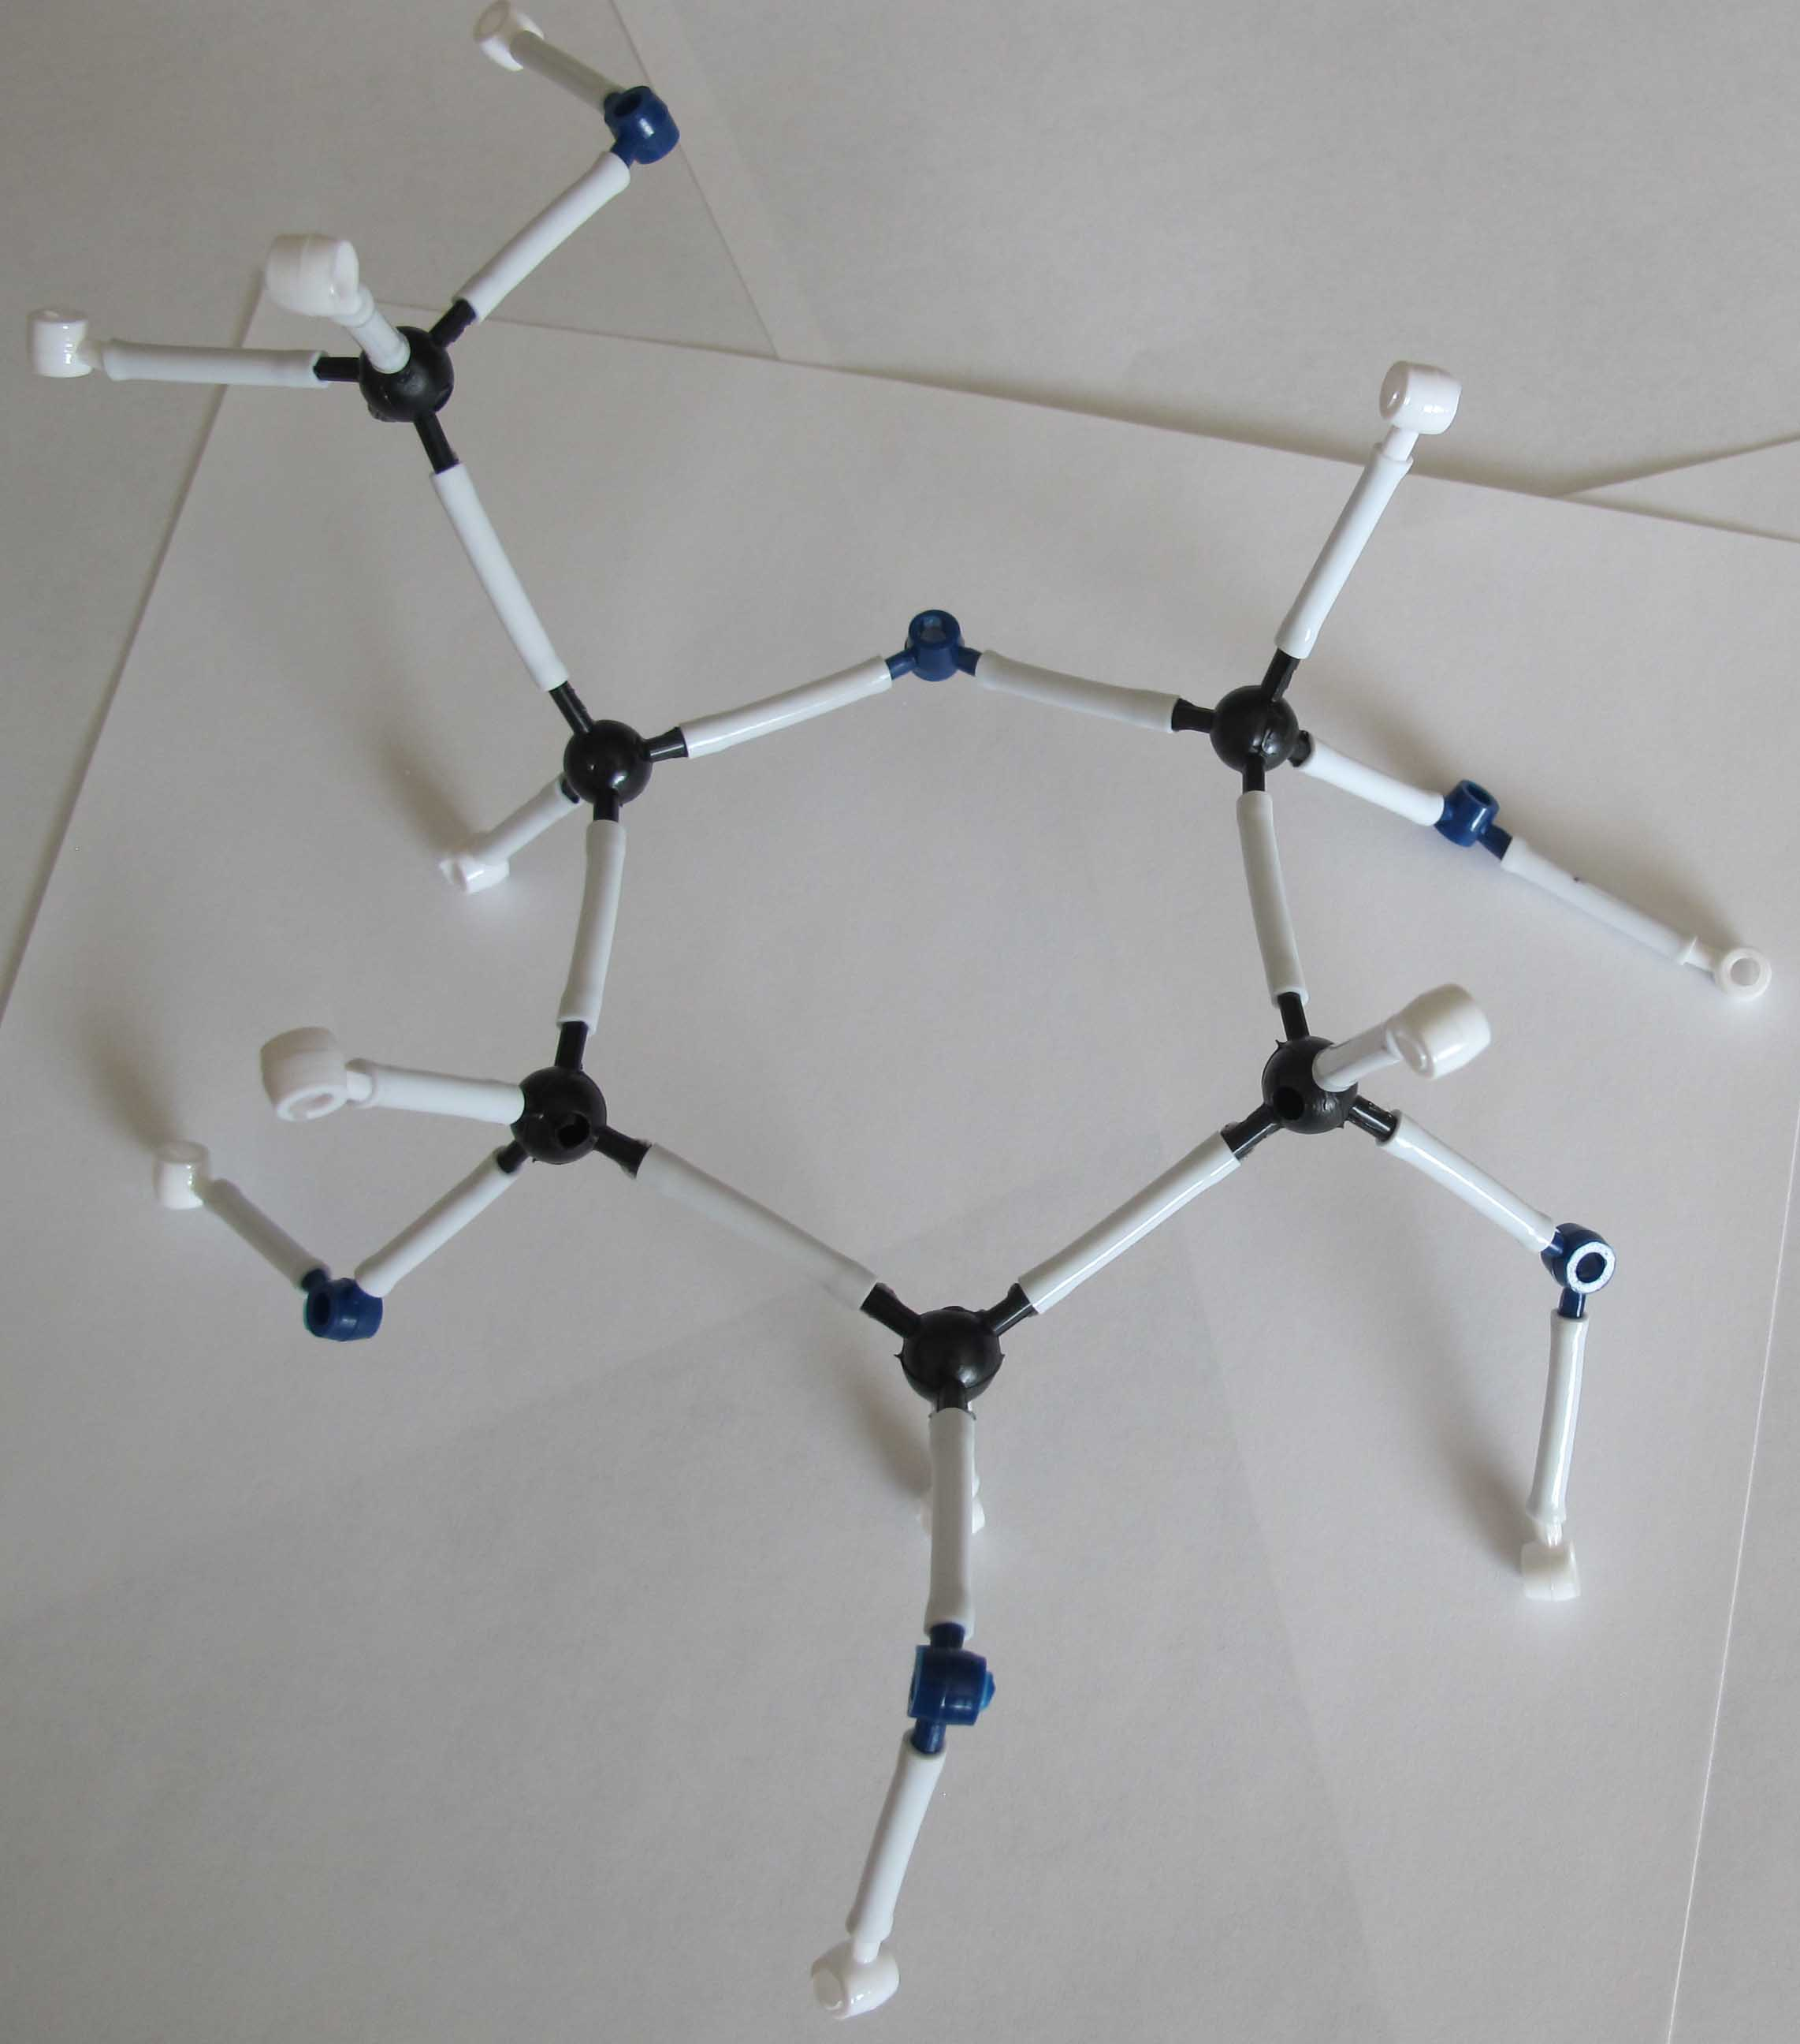
Move to the other four carbons on the ring. Attach 1 oxygen and 1 hydrogen to these carbons. Then attach another hydrogen to each oxygen. Make sure it looks similar to the image on the right.
Step 3: Answer Questions About Your Reactants: Look at your glucose and oxygen molecules. Using your worksheet, answer the questions about these two molecules. What atoms do these molecules have, and do they have chemical energy?

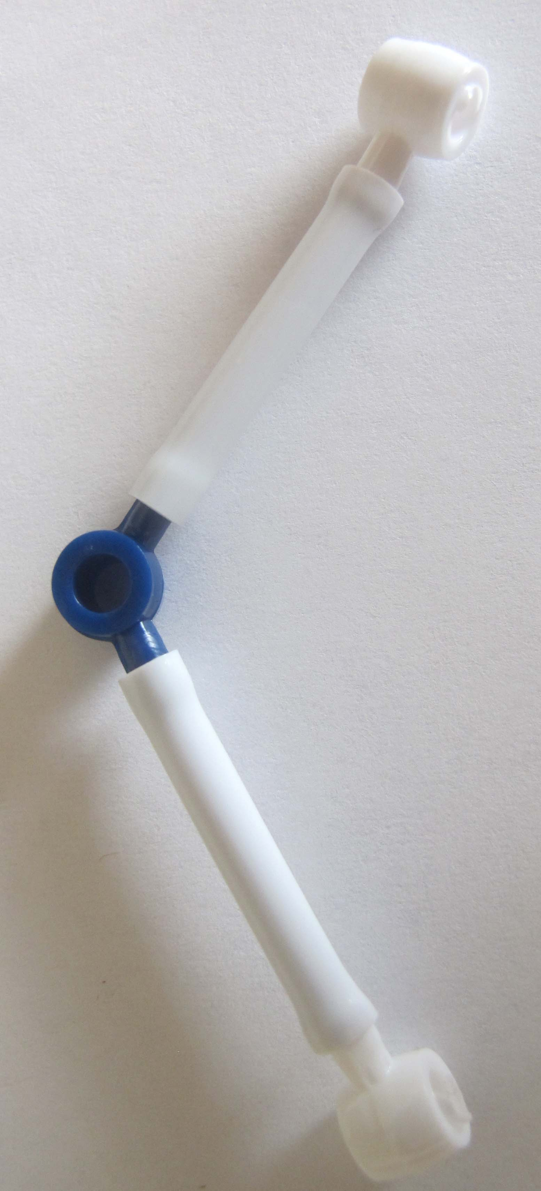
Step 4: Cellular Respiration Happens: In cell respiration, decomposer cells break down glucose and oxygen and rearrange the atoms into CO₂ and H₂O. Take apart the glucose molecule and remove 1 oxygen atom from all your oxygen molecules. Leave bonds connected to as many oxygen atoms as possible.

Step 5: Build Your Water Molecules: Water contains 1 oxygen atom and 2 hydrogen atoms. Build 6 of these molecules.

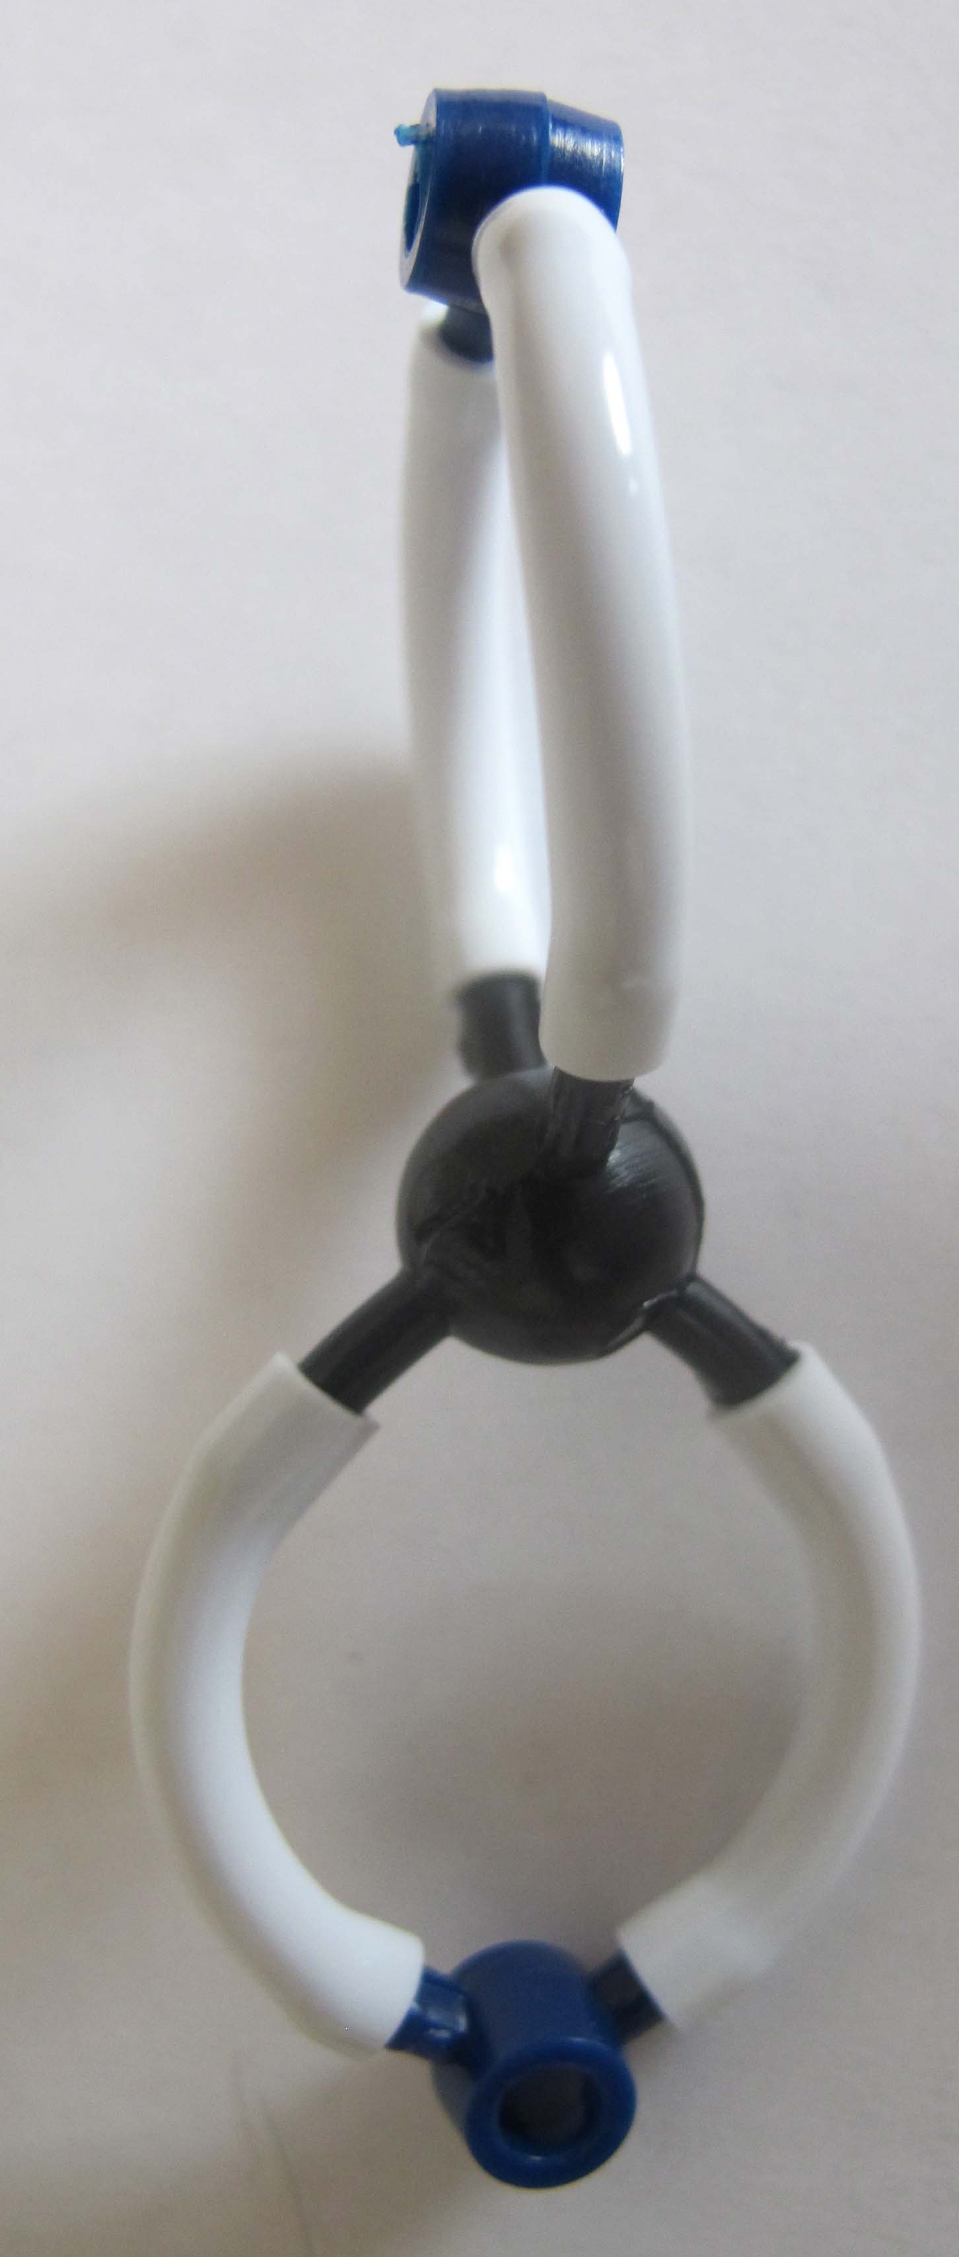
Step 6: Build Your Carbon Dioxide Molecules: Carbon dioxide contains 1 carbon atom and 2 oxygen atoms. There are two bonds between the carbon atom and oxygen atoms (called a “double bond”). Build 6 of these molecules.

Now, answer and discuss the questions on your worksheet.

Name:_____________________ Period:____ Date:_________

Worksheet with Commentary: Changing Dead Plants And Animals To Gases
Before Viewing the PowerPoint
When a mushroom grows, it gets energy from organic materials. Explain your ideas about how a fungus can use chemical energy from organic materials to grow.
1. Transformation of materials when mushroom cells function
Materials the mushroom uses: List your ideas about the main organic and inorganic materials that a mushroom needs for energy. (Hint: Don’t forget gases.) Students should be able to think back to previous lessons to answer this question and come up with a fairly comprehensive list including carbohydrates, fat, protein, minerals, water, etc. They may not think about oxygen at this point as it has not been mentioned much.  1.  2.  3.  4. | Transformation of materials in the mushroom cells: Explain how you think those materials might be changed when the fungus uses them for energy.  Most students will have Level 2 or 3 explanations and may convert matter to energy.
Use the process tool to show your ideas about a chemical change that supplies mushroom cells with energy. This is a “translation” task: Can they take the key words from their explanations and put them appropriately into the process tool diagram?

2. Movement of materials to the mushroom cells
In order for the mushroom cell to function, it must get materials from somewhere. Explain your ideas about how the materials get to the mushroom cell.
Response should be similar to digestion/biosynthesis lesson.

Name: _____________________ Period: ______ Date: _________
Using molecular models
You will use molecular models to show how decomposers change organic matter (especially dead organic matter) into other forms of matter. Record what happens to the atoms and bonds during this process. Use the molecular models to figure out how glucose combines with oxygen in cellular respiration:
- Follow the instructions on the handout to make models of a glucose molecule (C₆H₁₂O₆) and about 7 oxygen molecules (O₂, with a double bond)
- The decomposer’s cells can break the bonds in the glucose and oxygen molecules, so you can take them back apart.
- Now they can recombine into carbon dioxide (CO₂) and water vapor (H₂O), releasing chemical energy for the work of the muscles. Make as many of these molecules as you can.
- Figure out numbers of molecules:
  - How many O₂ molecules do you need to combine with one glucose molecule? 6
  - How many CO₂ and H₂O molecules are produced from one molecule? 6 each
- Write the chemical equation for the cellular respiration reaction:

C₆H₁₂O₆ + ? O₂ → ? CO₂ + ? H₂O

C₆H₁₂O₆ + 6 O₂ → 6 CO₂ + 6 H₂O

Use the table below to account for all the atoms and bonds in your models.
 | Matter |  |  | Energy
 | How many  carbon atoms | How many  oxygen atoms | How many  hydrogen atoms | Chemical energy: Yes or No?  (C-C; C-H Bonds)
Began with…
Glucose | 6 | 6 | 12 | Yes
Oxygen | 0 | 2 | 0 | No
End with…
Carbon Dioxide | 1 | 2 | 0 | No
Water | 0 | 1 | 2 | No

Name: _____________________ Period: ______ Date: _________
Explaining how Decomposers Function: After Building Molecular models, Reading about Decomposition, and Viewing the PowerPoint
Describe your revised ideas about how a fungus can use chemical energy from organic materials to grow and function.
1. Transformation of materials when mushroom cells function
Materials the mushroom uses: List your ideas about the main organic and inorganic materials that a mushroom needs for energy. At this point, students should be able to answer this question correctly.  1.  2.  3.  4. | Transformation of materials in the mushroom cells: Explain how you think those materials might be changed when the fungus uses them for energy. Students should now be able to describe the basic process of cellular respiration, explaining that the atoms of organic molecules (with C-C and C-H bonds) are rearranged to form inorganic molecules (CO₂ and water vapor), transforming chemical energy into usable energy and heat, and releasing the waste gases to the air.
Use the process tool to show your ideas about a chemical change that supplies mushroom cells with energy. Again, the key question here is whether the process tool is consistent with their written explanations.
2. Movement of materials to the mushroom cells
In order for the mushroom cell to function, it must get materials from somewhere. Explain your ideas about how the materials get to the mushroom cell.
Students should be able to explain that food polymers are broken down into much smaller monomers during digestion, and that these are carried by the circulatory system to cells where they are used for cellular respiration.

3. Checking your explanation
Does your explanation follow the principles that apply to chemical changes?
Yes No Not sure Conservation of matter: Materials (solids, liquids, or gases) change into other materials, but matter is not created or destroyed.
Yes No Not sure Conservation of mass: The masses of reactants and products are equal.
Yes No Not sure Conservation of energy: Energy is not created or destroyed.
Yes No Not sure Conservation of atoms: Atoms are not created or destroyed.
For these questions note the accuracy of their evaluations. If their explanation is not consistent with the principles, are they aware of it? How confident are they in applying the principles?

Sample data:
Modeling Decomposer Respiration

Sample Data (red font denotes PEAK CO₂ flux levels) BY ADDITIVE
Soil Sample | Additive | Start | 10-min | 30-min | 12-hours
Yard Soil | Control | 1767 | 2709 | 2679 | 1446
Forest Soil | Control | 1767 | 2515 | 2608 | 1852
Yard Soil | Sugar | 1767 | 2240 | 2200 | 1677
Forest Soil | Sugar | 1767 | 2612 | 2704 | 10027
Yard Soil | Starch | 1756 | 1862 | 1193 | 8277
Forest Soil | Starch | 1756 | 1950 | 2201 | 9951

Sample Data (red font denotes PEAK CO₂ flux levels) BY SOIL SAMPLE
Soil Sample | Additive | Start | 10-min | 30-min | 12-hours
Yard Soil | Control | 1767 | 2709 | 2679 | 1446
Yard Soil | Sugar | 1767 | 2240 | 2200 | 1677
Yard Soil | Starch | 1756 | 1862 | 1193 | 8277
Forest Soil | Control | 1767 | 2515 | 2608 | 1852
Forest Soil | Sugar | 1767 | 2612 | 2704 | 10027
Forest Soil | Starch | 1756 | 1950 | 2201 | 9951

Name:_____________________ Period:____ Date:_________

Worksheet with Commentary: Evidence of Decomposers Living In Soil
Decomposers living in soil can take many forms. Some we can see with our eyes while many are invisible to us without microscopes. Today we are going to “feed” soil microbes two different types of food – sugar and starch – and watch how the soil microbes respond to the addition of food.

Predictions
 |  | Explain your prediction
If we measure CO₂ around a sample of soil with nothing added to it, what do you think will happen to the CO₂ levels? | ◻ increase  ◻ be the same  ◻ decrease | Students should provide some justification for their prediction based on prior knowledge or evidence (e.g., they may refer back to previous lessons or their Jell-O decomposer investigation).
If we feed sugar to the soil microbes, what do you think will happen to CO₂ levels in the air around the microbes? | ◻ increase  ◻ be the same  ◻ decrease
If we feed starch to the soil microbes, what do you think will happen to CO₂ levels in the air around the microbes? | ◻ increase  ◻ be the same  ◻ decrease

Observations Should look similar to the sample data handout
Soil Type | Additive | Starting CO₂ | 5 minutes | 10 minutes | ___ minutes

Which soil sample do you think has the most decomposers? Explain why you think this using the evidence above.
This will depend on whether the soil has been treated with fertilizers and other factors, but regardless their explanation ought to be consistent with the data they have collected (higher CO₂ readings indicate a greater number of soil microbes).

Core Lesson 6: Coaching and Fading for Decomposition

Time/Duration: 25 minutes
Activity 1: Application Questions ~25 minutes

Guiding Question:

Model Response:
Alex | Blake | Carmen

Learning Objectives:
Students need to recognize that the process of cellular respiration in decomposition is the same as in all other living organisms. They need to understand that, as in combustion, the energy produced from respiration comes from high-energy bonds in organic materials (those containing C-C and C-H bonds).

Rationale & Background:
Up to this point in the unit, students have investigated only a few different situations involving decomposition (Jell-O and mold, mushrooms), but in their lifetimes they have likely experienced decomposition in several contexts. This activity gives them the opportunity to explore other instances of decomposition, some with which they are familiar and some which may be new to them. Students should also be able at this point to make connections to other units, particularly the Animals and Systems and Scale units, and explain how the process of decomposition is similar to animal metabolism and combustion.

Lesson Description:
The purpose of this lesson is to have students apply all that they have learned about decomposition in this unit to a novel context, and to make connections to past units and concepts. Students will work singly or in groups to select a scenario involving decomposition and explain the chemical processes taking place. They will use the process tool to do this, and may also model the process using the molecular model kits if they so wish. They will then explain how the process of cellular respiration is similar to combustion.

Lesson Materials:
Per Student
Worksheet Other Examples of Digestion, Biosynthesis, and Cellular Respiration in Decomposers (2 parts)

Activity 1: Application Questions

Time: 25 minutes

Rationale & Description:

Directions:
- Pass out the worksheet Other Examples of Digestion, Biosynthesis, and Cellular Respiration in Decomposers to students, either individually or in groups.
- Have students choose a novel scenario that they will explain by applying what they have learned. You can have students choose from the list provided on the worksheet or supplement with additional examples of your choosing – or even have students come up with examples from their own experience.
- Students will complete the backside of the handout by answering the questions and filling out the process tool based on their explanations and predictions. They may also use the molecular model kits to illustrate the process and/or help them reason about what is happening.
- In groups or as a whole class, ask students to answer the question about connecting to combustion. The goal is that they can see that the energy in both combustion and cellular respiration comes from the bonds in organic molecules.
- Time permitting, ask the students to answer the final two questions about conservation of matter. Have some examples prepared in case students cannot think of any. Students should be able to tell you that matter is neither created nor destroyed, and should try to explain what is actually happening in each example that accounts for the loss or gain of mass from the system. Tie this back to other lessons from this or previous units.

Worksheet with Commentary: Other Examples of Digestion, Biosynthesis, and Cellular Respiration in Decomposers
Questions about Decomposition

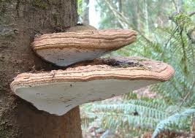
1. Choose two examples of other changes involving decomposition:
- Leaves fall from trees and decay on the forest floor
- Cheese that is left in the refrigerator too long gets moldy
- Shelf fungus grows on a dead tree (see picture)
- A farmer grows clover as a cover crop, then plows it into the soil, releasing nutrients for her vegetable crops (hint: clover has lots of protein, and some decomposers can use amino acids as an energy source for cellular respiration)
- A farmer leaves wet hay in his barn, and it heats up so much that it catches on fire (for a 5-minute video, see http://www.youtube.com/watch?v=zRNCrHqD0zE)
2. Use the Process Tool and questions on the next two pages to predict what will happen in your examples.
3. (Optional): Use molecular models to show what happens inside the cells of the decomposer.

Questions about Other Chemical Changes
Connect to combustion: Of the three kinds of chemical changes that you studied in decomposers:
- Digestion
- Biosynthesis
- Cellular respiration
Which change is most like combustion, the chemical change that you studied in Systems and Scale? Explain your reasoning.
Students should recognize that combustion is most similar to cellular respiration, and that in both processes organic substances (like glucose or ethanol) are oxidized. The atoms in the organic molecules are rearranged into lower-energy, inorganic molecules (CO₂ and water) and energy is released (kinetic and heat in cellular respiration, heat and light in combustion).

Stump the class: The Law of Conservation of Mass says that mass is conserved in EVERY chemical and physical change, including all changes that occur in animals. Can you think of an example of decomposition where mass is not conserved?
1. Try to think of an example where mass seems to disappear—the products at the end are lighter than the reactants at the beginning. Can anyone in the class suggest a possible explanation?
2. Try to think of an example where mass seems to be created—the products at the end are heavier than the reactants at the beginning. Can anyone in the class suggest a possible explanation?
Name: _____________________ Period: ____ Date: ________
Predicting and Explaining an Example of Chemical Change in decomposition
1. Write your own explanation for what chemical changes are involved in this process.
Students should be able to tell a coherent story at this point, drawing from previous lessons.

2. Predict what happens to the masses of materials involved in this process.
Students should be able to predict what gains or loses mass, but above all should conserve matter.

3. Explain what happens to the chemical energy stored in the C-C and C-H bonds of organic materials.
Students should be able to explain that the energy is transformed into kinetic energy and heat.

4. Use the process tool to identify the reactants, products, and energy changes. Can students translate their predictions/explanations into the process tool?

5. Does your explanation follow the principles that apply to chemical changes?
Yes No Not sure Conservation of matter: Materials (solids, liquids, or gases) change into other materials, but matter is not created or destroyed.
Yes No Not sure Conservation of mass: The masses of reactants and products are equal.
Yes No Not sure Conservation of energy: Energy is not created or destroyed.
Yes No Not sure Conservation of atoms: Atoms are not created or destroyed.

